Name: ___________________________________ Period: _________ Test date: _____________________
*This review is due the day of the test & will be a grade.

Maps Unit Test Review
Please complete each of the following sections using your Maps Unit packet, a world map, your iPad, and/or any other resource that will help you master each concept for the test.

I. Elements of a Map: Answer the following questions and be able to identify each element on a map.
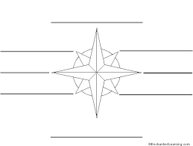
1. Correctly label the cardinal and intermediate directions on a compass rose

Use the map of Fiesta Texas below to answer questions 2-4:

2. What is the title of this map? _____________________________________
*Please note: The title of a map can also be the theme of a map.

3. Looking at the Map Legend, list one of the symbols and what it stands for: ______________________

4. List two labels shown on the map (*Please note: Labels = Names, which are found directly on the map)
1)___________________________
2)___________________________
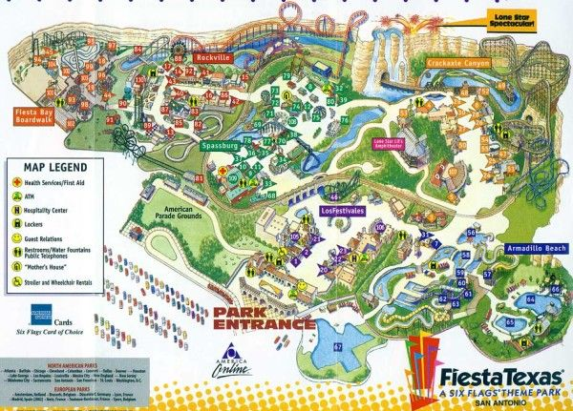

*Please note: You can find this review under the Maps Unit resources on my website to view the maps more clearly and zoom in as needed.

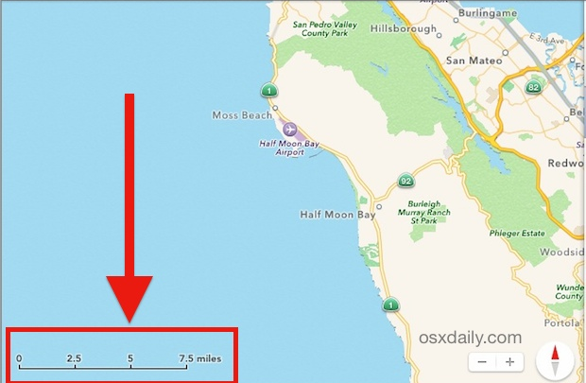

5. Using the scale, approximately how many
miles are between Moss Beach and Half
Moon Bay? __________

*You may use a ruler on these types of questions.

II. Matching: Using your maps packet or textbook glossary, define the following terms and be able to
match the term with its definition.

6. Political map: ________________________________________________________________________

7. Physical map: ________________________________________________________________________

8. Absolute location: _____________________________________________________________________

9. Globe: ______________________________________________________________________________

10. Map/Projection: _____________________________________________________________________

11. Hemisphere: ____________________________________________________

12. Lines of Latitude: _____________________________________________________________________

13. Lines of Longitude: ___________________________________________________________________

III. Absolute Location: Using the map of the U.S., list the coordinates of the following cities.
*Remember: List North or South first, followed by East or West. (examples: 78°N, 30°W or 23°S, 120°E)

For absolute location questions, ask yourself, “How far NORTH or SOUTH of the EQUATOR?” followed by,
“How far EAST or WEST of the PRIME MERIDIAN?”
*Please note: A full-sized
U.S. map can be found
next to Part I of the
Maps Test Review.
14. Washington, DC is located at ___________ , _____________
15. New Orleans, LA is located at ___________ , _____________
16. Houston, TX is located at ___________ , _____________
17. Miami, FL is located at ___________ , _____________
