# 

# **Name: __________________________________________ Period: ________ Date: _____________________**

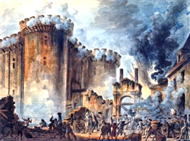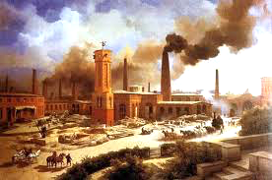

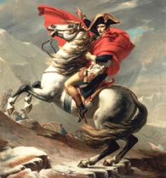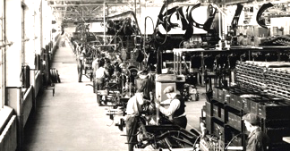**The Revolutions**

# **I. The Industrial Revolution – pp. 270-271 in the National Geographic textbook**

#### **Related image**List *two positive effects* of the Age of Exploration? 1) ___________________________________________ & 2) ____________________________________________________________

1. From the text, define **Industrial Revolution**: ____________________________________________ ___________________________________________________________________________________

**\* There are** **two types of revolutions** 🡪 ***a period of great change*** **or** ***a revolt*** (**ex:** **a coup d’état)**

3. The Industrial Revolution began in the 1700s in *which country*? ______________________

**\*** The new inventions and technologies of **Renaissance** & the **Age of Exploration** led to the **Industrial Revolution**

1. Which *industry* was the first to be transformed by the Industrial Revolution? __________________________
2. What *powered* the first machines? _____________________________________________
3. Which *machine* was invented by James Hargreaves in 1770? __________________________________
   1. What did this machine do? __________________________________________________________
4. What do you call the *system* in which machines were placed in large buildings and workers manufactured small part of the product in assembly lines? _________________________________________
5. What did James Watt invent in 1776? ______________________What was it powered by? _______________
6. As the Industrial Revolution spread throughout Europe in the late 1700s, what did *France* and *Belgium* manufacture? ______________________ What resource did *Germany* process? _______________________
   1. **Reflection question**: Railroad systems developed in the 1800s – how did the Industrial Revolution influence the building of railroads? ____________________________________________________

_________________________________________________________________________________

1. What were three of the major impacts that the Industrial Revolution had on *how people worked and lived*? 1) _______________________________________, 2) ________________________________________ & 3) _______________________________________________
2. List 3 (out of the 4) harsh conditions that *factory workers* faced: 1) __________________________________, 2) __________________________________________ & 3) ______________________________________
3. What effect did *open sewers* have? ______________________________________
4. 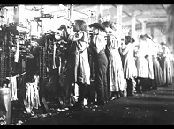What 2 things improved workers’ *quality of life*?

1) ______________________________ & 2) _________________________________________

1. Looking at the map & legend on p.271, which 3-4 countries in Europe had the *greatest number of*

*industries*? _______________________________________________________________________

1. From the map/legend on p.271, which resource/industry was most widespread throughout Europe?

_________________________ **\*Hint:** Count the *number of symbols* for each resource/industry

a. What *purpose* did this resource serve at the time that made it so important? _______________________

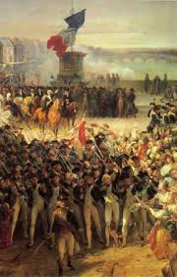

**II. The French Revolution – pp. 272-273**

## 16. By the summer of 1789, the Industrial Revolution had not yet reached France (which would have

## made prices of goods cheaper). What *two additional factors* led the French to start a revolution?

1) _______________________________ & 2) _____________________________________

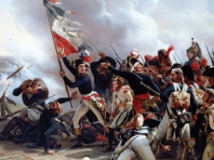17. Describe the *event* started the French Revolution on July 14, 1789? __________________________________ ________________________________________________________________________________________

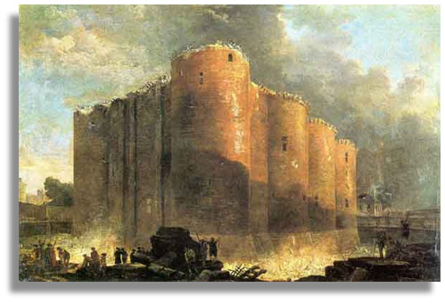

a. Using the picture & caption on p.272, what were the French citizens looking for

in question #17? ________________________________________________

b. Using your iPad to research, what *holiday* do the French celebrate on July 14th to this day?

__________________________________________

18. List the *groups of people* in each of the Three Estates in *French society*:

**First Estate** 🡪 ___________________________; **Second Estate** 🡪 ____________________________;

**Third Estate** 🡪 ______________________________________________________________________

19. The *Third Estate* was influenced by the Age of Enlightenment, which stressed what?

_____________________________________________

a. Which war did the *thinkers* of the Enlightenment first inspire? __________________________________

20. Which leader refused the Third Estate’s demands for change? _________________________________

a. In response, the Third Estate formed the National Assembly where they wrote the ***Declaration of the Rights of Man and of the Citizen***, which guaranteed what 3 things to the citizens of France? 1) ___________________, 2) _______________________ & 3) ________________________________

21. Which *group* *of radicals* seized power and formed the National Convention in 1792? ______________________

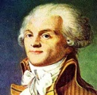 a. Which two leaders did this group *execute*? 1) ___________________ & 2) ____________________________

22. Which leader led the **Reign of Terror**? ______________________________________________

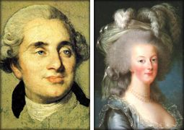a. What happened to this leader in 1794? _____________________________________________

23. What is the name of the machine that was used to kill an estimated 40,00 people during the

Reign of Terror to execute “enemies of the revolution”? ______________________________

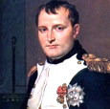24. How did Napoleon Bonaparte come to power in France? _____________________________________________

a. What did Napoleon declare himself in 1804? ____________________________________________

25. Who finally defeated Napoleon in 1815? 1)_____________________ & 2) ______________________

Napoleon was first exiled to the island of Elba, where he escaped and resumed power, only to be defeated again in the battle of Waterloo and sent to an island off the coast of Africa. He died 6 years later, but his body was returned to Paris in 1840, where his tomb can still be visited in the Les Invalides Museum: <http://mikestravelguide.com/things-to-do-in-paris-visit-the-army-museum-and-the-tomb-of-napoleon/tomb-of-napoleon-musee-de-larmee-invalides-paris-france/>