Name: ____________________________________ Period: _____________ Date: ____________________
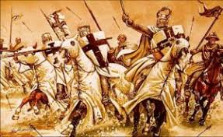
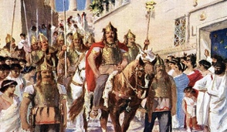
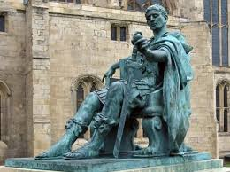
The Middle Ages
The Roman Empire – pp. 262-263
I. Rome’s Decline:
1. For how many years was the Roman Empire the most powerful in the world? _________________
2. Around what year did Rome have a series of poor rulers? __________________
3. Which tribe began invading the empire from the north? _______________________________
a. What did the Romans refer to these people as? ________________________________________
4. Which emperor moved the capital city of the weakened empire from Rome to Byzantium in 330 A.D.?
_______________________________________________
- Which present-day country was the new capital located? ______________________________
- What name was the new capital given? ________________________________________
- What did this emperor make lawful throughout the Roman Empire? _____________________________
5. What happened to the Roman Empire in 395 A.D.? ______________________________________________ 6. What happened in 476 A.D.? ________________________________________________________________
a. Which half of the Roman Empire still stood? __________________________
7. List three legacies left behind by Roman engineers: 1) ____________________________________________,
2) ________________________ & 3) _____________________________
8. Which language did Romans speak that became the basis for Romance languages? _____________________
9. What are two examples of Romance languages? 1) ____________________ & 2) _____________________
Middle Ages and Christianity – pp. 264-265
Please note: If there is an asterisk (*) next to the question, please research it on your iPad to find the answer.
10. Looking at the Main Idea box at the top of the page, which two things influenced Western Europe the most during the Middle Ages: 1) __________________________________ & 2) __________________________
11. What period did Western Europe enter after the fall of the Roman Empire? ___________________________
a. *What two other names is this period known as? 1) ____________________ & 2) ___________________
b. This period lasted from the year _______________ until _______________ A.D.
12. While the Western Roman Empire fell in 476 A.D., the Eastern Roman Empire (or Byzantine Empire) fell in 1453 to the Ottomans after they captured Constantinople. *After the fall of the Eastern Roman Empire, what was Constantinople renamed? ___________________________________
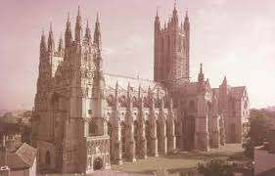
13. In 1054, Christianity divided into which two parts?
1) ______________________________________ in _____________________ Europe
2) ______________________________________ in _____________________ Europe
14. What 3 key roles did the Church play in government? 1) _________________________________,
2) ____________________________________, & 3) ____________________________________

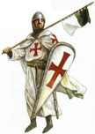
15. The Catholic Church began the Crusades in the year _______________, which ended in ________________
a. Define Crusades - ______________________________________________________________________
_____________________________________________________________________________________

16. Which German group unified most of Western Europe from 400 to 800 A.D.? ________________________
a. Who was this group’s most important leader? ______________________________________
b. After this leader’s death in 814 A.D., warfare broke out and Western Europe became divided. To provide security for each kingdom, what system was developed? _______________________________________
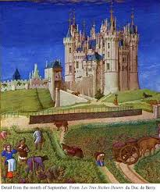
17. The Feudal System pyramid structure:

a._____________ - owned vast territory

b.___________________ - powerful noblemen (“landlord”) who owned land & lived on a manor
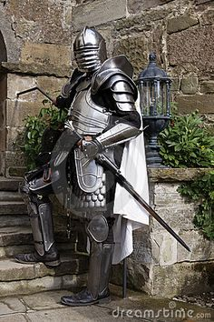
c.___________________________ - given pieces of land & pledged loyalty and service to the lord
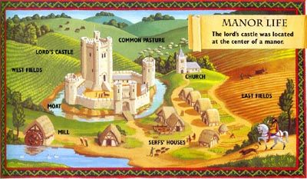
d.___________________________________ - farmed lord’s land in return for shelter & protection

18. What brought an end to the feudal system? ______________________________________________
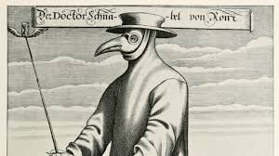
19. Which deadly disease swept through Europe in 1347 and weakened the feudal
system? _____________________________________
a. *Using your iPad, research how many millions of people were believed to be
killed by this highly contagious disease: ____________________________
b. After the workforce was greatly reduced, what were workers offered as a
result (which also caused farmers to leave the countryside)? ____________________________

