Name: __________________________________ Period: ______________ Date: _____________________
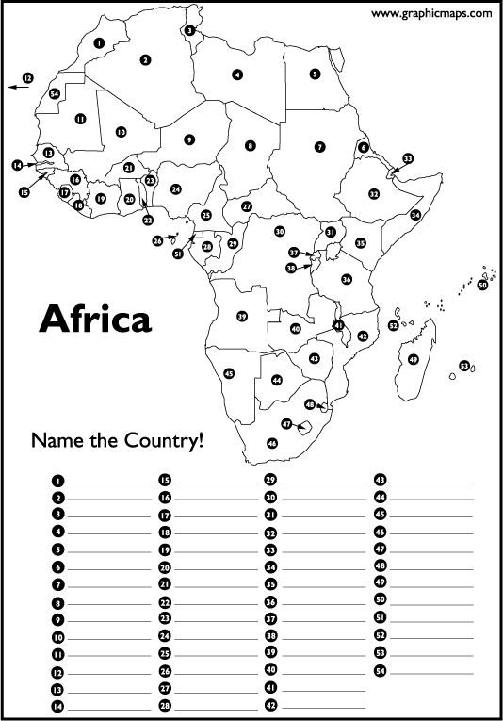
Using A27 in your textbook or your iPad, label the political map of Africa in the spaces below.

Physical Map of Africa: Using A26 in your textbook or your iPad, complete the following.
Outline and label the following landforms
using the colors listed below:

Green (1-3): Brown (4-6):
1. Cape of Good Hope 4. Sahara Desert
2. Atlas Mountains 5. Kalahari Desert
3. Mt. Kilimanjaro 6. Namib Desert

Bodies of water: Label and trace over 1-5 in blue; and ONLY label 6-10 in blue:

1. Suez Canal 6. Atlantic Ocean
2. Lake Victoria 7. Indian Ocean
3. Congo River 8. Red Sea
4. Nile River 9. Mozambique Channel
5. Niger River 10. Mediterranean Sea
