Name: _____________________________________ Period: ______________ Date: _____________________
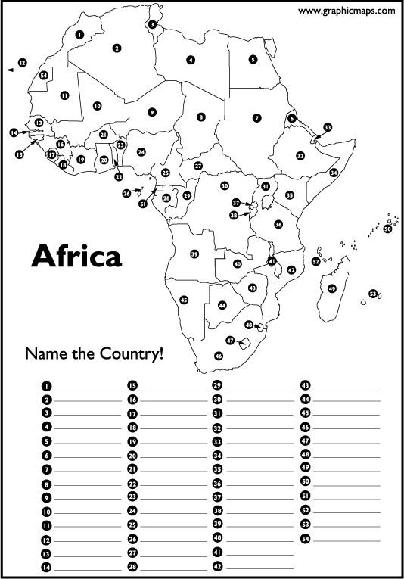
Using A27 in your textbook or your iPad, label the political map of Africa in the spaces below.

1. ______________________ 15. ______________________ 29. ______________________ 43. ____________________
2. ______________________ 16. ______________________ 30. ______________________ 44. ____________________
3. ______________________ 17. ______________________ 31. ______________________ 45. ____________________
4. ______________________ 18. ______________________ 32. ______________________ 46. ____________________
5. ______________________ 19. ______________________ 33. ______________________ 47. ____________________
6. ______________________ 20. ______________________ 34. ______________________ 48. ____________________
7. ______________________ 21. ______________________ 35. ______________________ 49. ____________________
8. ______________________ 22. ______________________ 36. ______________________ 50. ____________________
9. ______________________ 23. ______________________ 37. ______________________ 51. ____________________
10. _____________________ 24. ______________________ 38. ______________________ 52. ____________________
11. _____________________ 25. ______________________ 39. ______________________ 53. ____________________
12. _____________________ 26. ______________________ 40. ______________________ 54. ____________________
13. _____________________ 27. ______________________ 41. ______________________
14. _____________________ 28. ______________________ 42. ______________________

Name: _____________________________________ Period: ______________ Date: _____________________
Using A26 in your textbook and the maps posted on Google Classroom, complete the physical map of Africa.
Africa’s landforms – follow the directions below:

Draw/label in green: Draw/label in brown:
1. Cape of Good Hope 6. Sahara Desert
2. Atlas Mountains 7. Kalahari Desert
3. Mt. Kilimanjaro 8. Horn of Africa (Somali
4. Congo Basin Peninsula)
5. Virunga Mountains

Outline/trace & label the following bodies of water in blue:

1. Suez Canal 7. Atlantic Ocean
2. Lake Victoria 8. Indian Ocean
3. Congo River 9. Red Sea
4. Nile River 10. Mediterranean Sea
5. Niger River 11. Mozambique Channel
6. Strait of Gibraltar 12. Gulf of Guinea

