Name: _________________________________ Period: ________ Date: ______________________
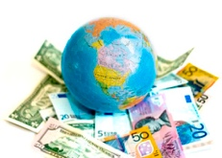
Economic Geography

Read pages 62-63 in the National Geographic textbook to complete the following.
1. Define economy - ____________________________________________________________ ___________________________________________________________________________
Economic Activity
2. Economic activity is the production of which two things?
1) ______________________ & 2) ______________________
3. Economic activity is divided into 3 sectors – define and list examples of each from the textbook.
1) Define Primary Sector: __________________________________________________________
a. Examples: ___________________________________________________________________
2) Define Secondary Sector: ________________________________________________________
a. Examples: ___________________________________________________________________
3) Define Tertiary/Third Sector: ____________________________________________________
a. Examples: ___________________________________________________________________
Factors of Production
4. A country is more likely to have a strong economy if it has each of the following four factors of production, which you will define below:
1) Define Land - _______________________________________________________________ ___________________________________________________________________________
2) Define Labor - _______________________________________________________________ ___________________________________________________________________________
3) Define Capital - ______________________________________________________________
_____________________________________________________________________________
4) Define Entrepreneurship - ____________________________________________________ ____________________________________________________________________________

Economic Systems
5. Define Economic System - ________________________________________________________
______________________________________________________________________________
6. Describe each of the four main economic systems that are found around the world:
1) Traditional economy - _______________________________________________________ ___________________________________________________________________________

2) Free enterprise economy - ____________________________________________________ ___________________________________________________________________________

3) Command economy - ________________________________________________________ ___________________________________________________________________________

4) Mixed economy - ____________________________________________________________ ___________________________________________________________________________
Economic Indicators
7. Define Gross Domestic Product (GDP): ____________________________________________ ______________________________________________________________________________
8. What is meant by GDP per capita? ________________________________________________ ______________________________________________________________________________
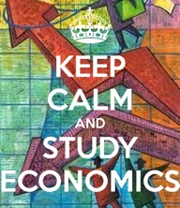
9. Other than GDP, what three indicators are used to measure the strength of a country’s economy? 1) __________________________, 2) _______________________ & 3) ______________________
Economic Indicators of Selected Countries (from the chart on p.63)
10. Which country has the largest population? __________________________
11. Which country has the largest GDP per capita? ____________________________
12. Using the economic indicators on this chart (GDP per capita, life expectancy, and literacy rate), which two countries have the strongest economies? 1) _______________________________ 2) _______________________________
13. Using the economic indicators on this chart (GDP per capita, life expectancy, and literacy rate), which country has the weakest economy? ____________________________________________
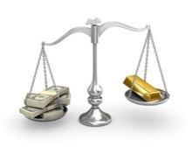
14. Looking at China on the chart, answer the following questions:
1) How big is China’s population? ______________________
2) What is China’s GDP? ______________________________
3) However, what is China’s GDP per capita? ______________________
4) Based on the numbers above, what conclusion can you make about China’s population and
GDP in relation to its GDP per capita? ___________________________________________
____________________________________________________________________________

