Name: ________________________________________ Period: ________ Date: ________________________
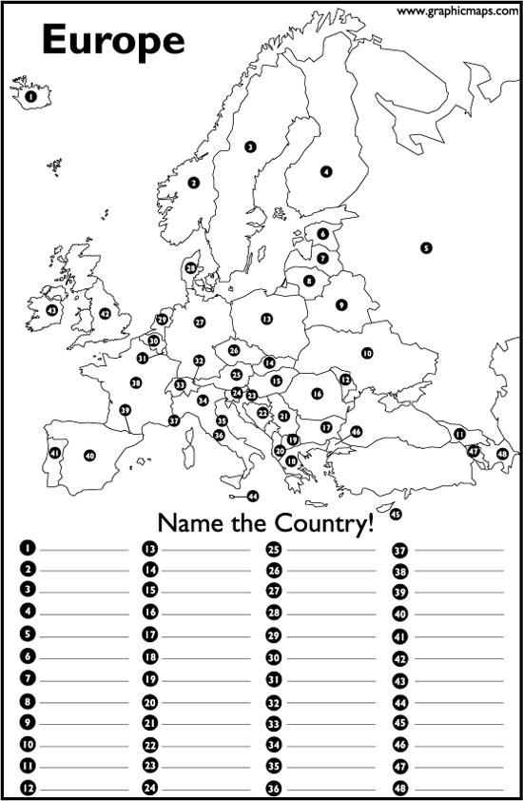
Using A20-A21 and A24 in your textbook or on your iPad, complete the political map of Europe.

1. ______________________ 13. ______________________ 25. ______________________ 37. ____________________
2. ______________________ 14. ______________________ 26. ______________________ 38. ____________________
3. ______________________ 15. ______________________ 27. ______________________ 39. ____________________
4. ______________________ 16. ______________________ 28. ______________________ 40. ____________________
5. ______________________ 17. ______________________ 29. ______________________ 41. ____________________
6. ______________________ 18. ______________________ 30. ______________________ 42. ____________________
7. ______________________ 19. ______________________ 31. ______________________ 43. ____________________
8. ______________________ 20. ______________________ 32. ______________________ 44. ____________________
9. ______________________ 21. ______________________ 33. ______________________ 45. ____________________
10. _____________________ 22. ______________________ 34. ______________________ 46. ____________________
11. _____________________ 23. ______________________ 35. ______________________ 47. ____________________
12. _____________________ 24. ______________________ 36. ______________________ 48. ____________________

