Name: ___________________________________ Period: __________ Date: ________________________
Using A9 and A14 in the National Geographic textbook, label the countries of North America (which includes the region of Central America).
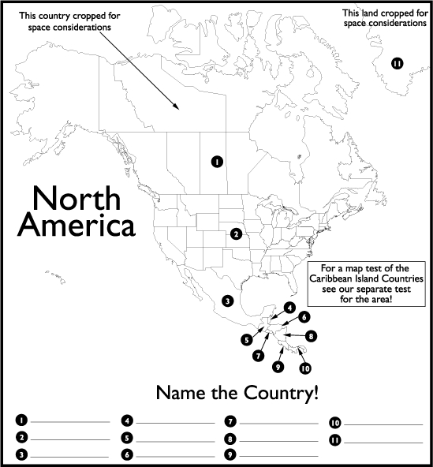

Countries of North America:

1. ______________________________
2. ______________________________
3. ______________________________
Countries of Central America:

4. ______________________________
5. ______________________________
6. ______________________________
7. ______________________________

This island is on the North American tectonic plate, but is a self-governing territory of the Kingdom of Denmark:

11. ___________________________

8. ______________________________
9. ______________________________
10. _____________________________

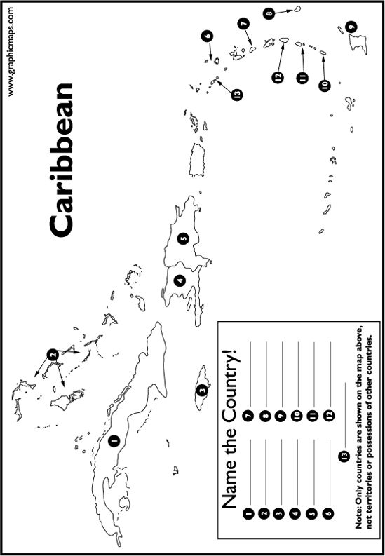
Using A14-A15 in the National Geographic textbook, label the following countries:
1. ______________________________ 8. _______________________________
2. _______________________________ 9. _______________________________
3. _______________________________ 10. _______________________________
4. _______________________________ 11. _______________________________
5. _______________________________ 12. _______________________________
6. _______________________________ 13. _______________________________
7. _______________________________
*To distinguish independent countries (#1-13) from territories of other countries, look for the names that are both BOLD and in ALL CAPS in the textbook.
Countries that dominated sea trade routes: England, France, the Netherlands, Portugal & Spain

