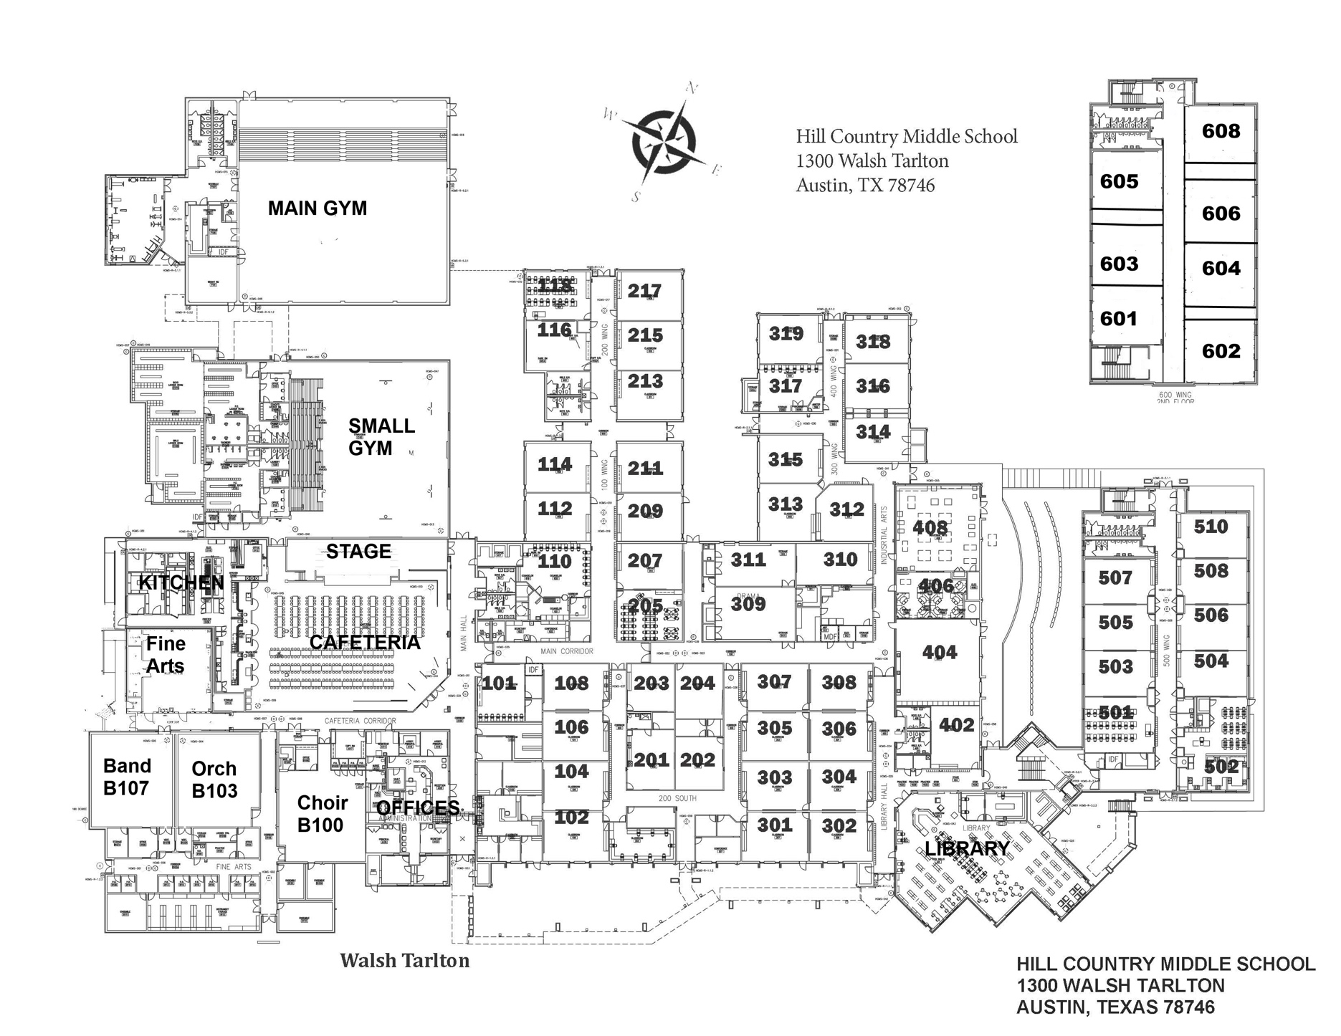

**Grading rubric:**

_____ Heading (5 points)

_____ Title (10 points)

_____ Conventions (10 points)  
 (spelling, capitalization & punctuation)

_____ Map key/legend (20 points)

_____ Use of color and/or colorful

symbols (15 points)

_____ Compass rose (10 points)

_____ Rough and final drafts

completed (20 points)

_____ Neat, clear, and easy to

read (10 points)

­­­__________ **Final daily grade**

**Back to School Night Legend/Key** – Please use a different color for each class and/or a colorful symbol that represents that class. (*Wheel = Small gym; P.E. = Main gym)

Color/symbol Subject – Teacher Color/symbol Subject – Teacher

1st - ___________ __________________________________ 5th - ___________ ______________________________________

2nd - ___________ __________________________________ 6th - ___________ ______________________________________

3rd - ___________ __________________________________ 8th - ___________ ______________________________________

4th - ___________ __________________________________ **\*Please note:** 7th period is advisory – parents will not meet your advisory teacher.

**Rough Draft**

Name _________________________________________________ Period ___________

118118