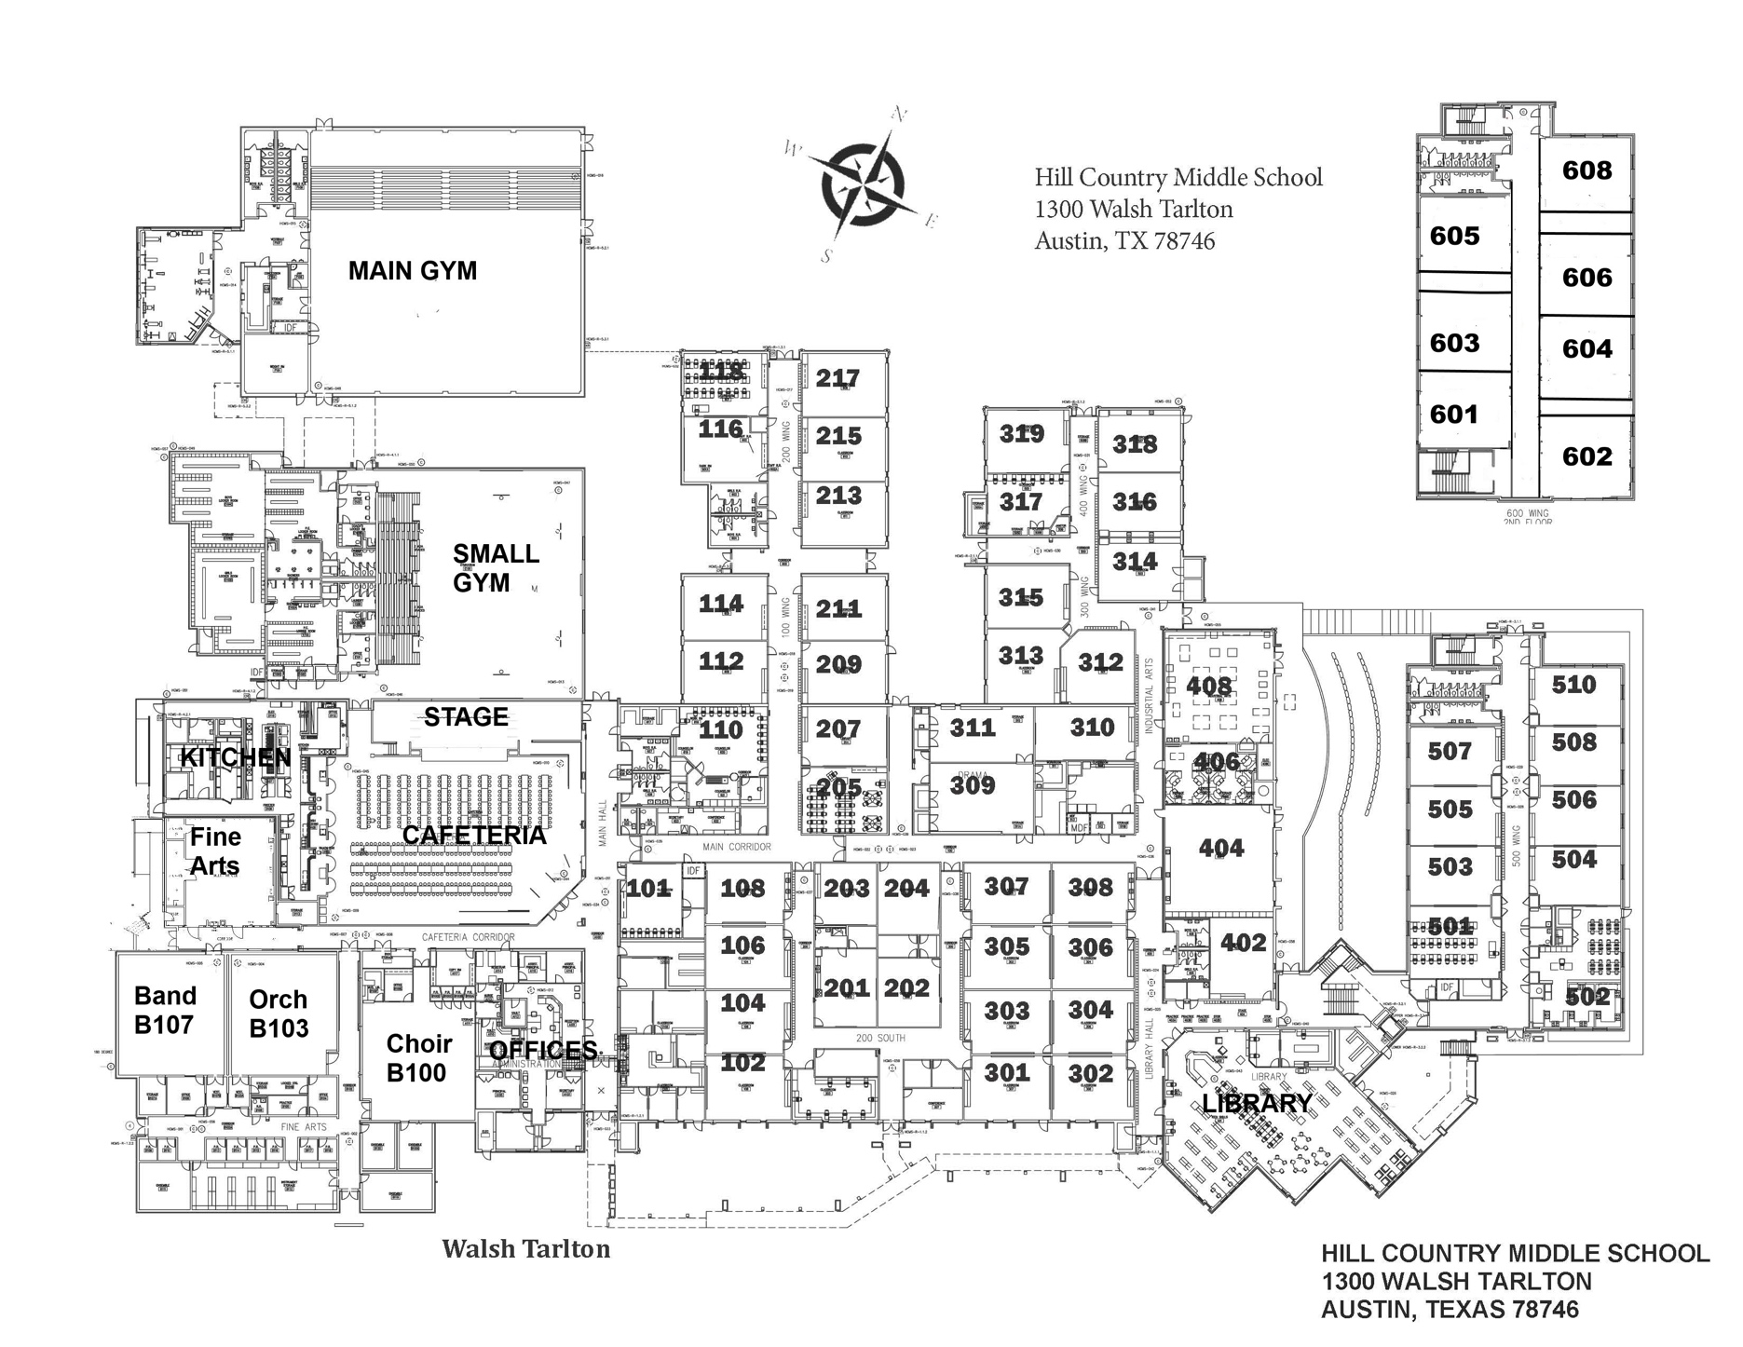

**Back-to-School Night Legend / Key** – Please use a different color for each class, which may include a symbol that represents that class. (*Wheel 🡪 Small Gym; *P.E. 🡪 Main Gym)

**Color/Symbol** **Subject – Teacher** **Color/Symbol Subject – Teacher**

1st - _____________________________________ 5th - _________________________________________

2nd - _____________________________________ 6th - _________________________________________

3rd - _____________________________________ 8th - _________________________________________

4th - _____________________________________ **\*Please note:** 7th period is advisory – parents will not meet your advisory teacher.

**Grading rubric:**

_____ Full heading (5 points)

_____ Title (10 points)

_____ Conventions (10 points)  
 - Spelling, capitalization & punctuation

_____ Map key/legend (20 points)

_____ Use of different colors for

each class (15 points)

_____ Compass rose (10 points)

_____ Rough & final drafts

completed (20 points)

_____ Neat, clear & easy to read

(10 points)

­­­__________ **Final daily grade**

**Rough Draft**

Name _________________________________________________ Period ___________

118118