Name: _____________________________________ Period: _________ Date: _______________________

**Renaissance Notes**

Please go to **Google Classroom** to access the PDF version of the former social studies textbook (which is also posted on my Social Studies Resources tab under Renaissance)

**The Renaissance – pp.301-306** (in former social studies textbook)

1. What is the name of the *military expeditions* that took place from the 11th to 13th centuries by Western European Christians to regain the Holy Lands from Muslims? __________________________
   1. **Background:** The Holy Land is important to which three religions? 1) ______________________, 2) ______________________ & 3) ______________________
2. The Crusaders traveled long distances on their mission to reclaim the Holy Land, which opened them up to what? _____________________________________
3. As Crusaders traveled across Southwestern Asia and North Africa, they rediscovered the ideas and achievements of which two civilizations? 1) ______________________ & 2) _______________________
4. 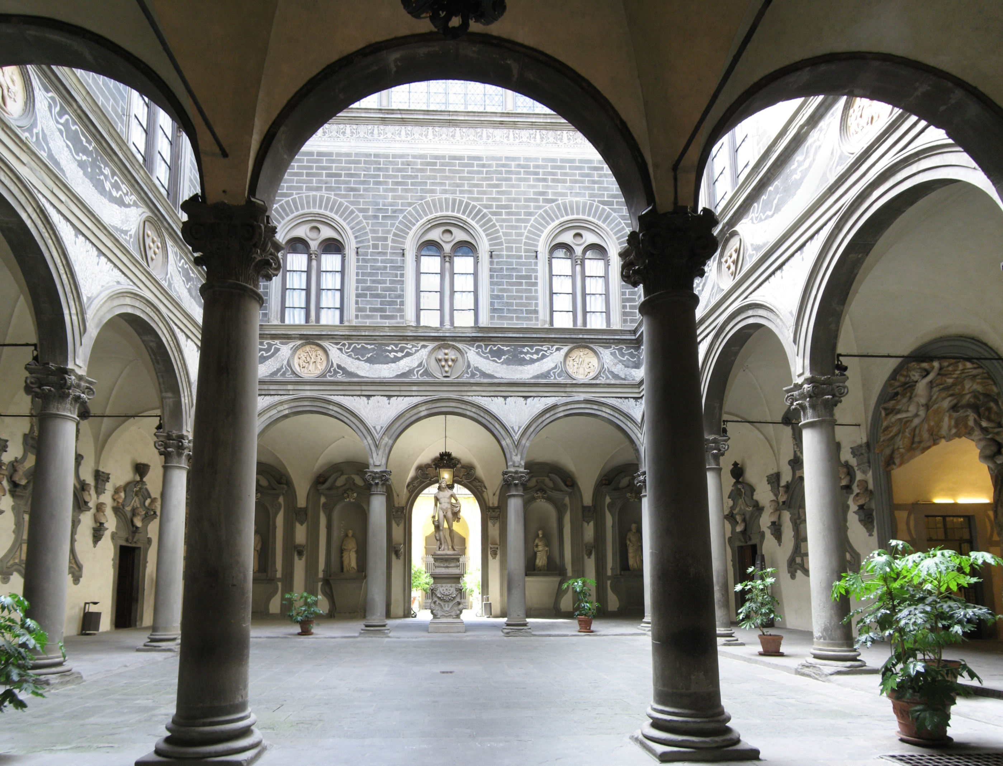This interest in the ancient world sparked a new era of creativity and learning in Western Europe from the 14th to 16th century, which is known as what? _______________________________ (French for “rebirth”)
   1. Where did this new era of creativity and learning begin? __________________________________

**Reflect:** What is significant about where this new era began?

1. Which 4 groups of people created great works of importance during this time, such as paintings, sculptures, buildings, and literature? 1) _________________________ 3) _________________________

2) _________________________ 4) _________________________

1. 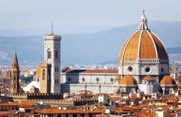**Region:** The Italian Peninsula was divided into many independent city-states during the 14th century. Which city-state was the most important economic and cultural center during the Renaissance, which dominated in banking, trade, and manufacturing? __________________________________
   1. 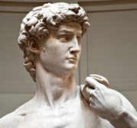**Region:** What building is a symbol of this city’s Renaissance past (which means “dome” in Italian and is *pictured to the left*)? ______________________________
2. Aristocrats were members of the wealthy class whose wealth came from what two things? 1) _________________ & 2) __________________ (rather than land, like in the Middle Ages)
   1. What two things did wealthy aristocrats place great emphasis on (that weren’t as important during the Middle Ages)? 1) ___________________________ & 2) ______________________________
3. What were wealthy citizens called that gave money to artists, scholars, architects, and designers to create great works of art (such as paintings, sculptures, buildings, and fountains)? _________________________
   1. 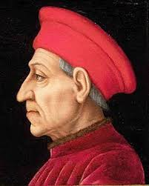**Biography:** The Medici family was among the most famous patrons of the Renaissance. Which two industries did this family gain their wealth? 1) ____________________ & 2) __________________ * The Medici, who were called the “Godfathers of the Renaissance,” were the first mafia family
   2. List 3 famous artists that this family supported: 1) ________________________________, 2) __________________________________ & 3) __________________________________
4. Most ***medieval*** ***art*** was based on what? ____________________________________
   1. However, **Renaissance art** included religious art, as well as what other *three types of art*? 1) ____________________, 2) ________________________ & 3) __________________________
5. Who was one of the most famous artists, scientists, engineers, and inventors of the Renaissance? ____________________________________________
   1. 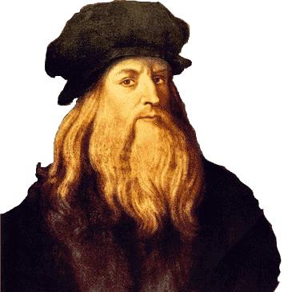List 2 of his most famous paintings: 1) _____________________ & 2) _______________________
   2. List the 3 ideas that he drew sketches of in the 1500s, hundreds of years before they were invented: 1) __________________________, 2) ______________________ & 3) ______________________

**\*** From this era, we get the term “*Renaissance man*,” which describes a person with many talents

or areas of expertise. *Who would be a modern-day example* *of a Renaissance man (or woman)*?

1. 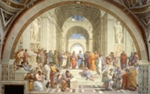**Connections to Math:** What is the technique called that artists started using during the Renaissance to show depth and distance (or 3-D) in their work? __________________________________
2. Which English writer wrote Romeo and Juliet, Macbeth, and many other popular plays (including Julius Caesar) during the late 16th and early 17th centuries? __________________________________________
3. Define **Reformation**: ___________________________________________________________________

_____________________________________________________________________________________

1. **Background:** What was the name of the book Thomas More wrote in 1516? ________________________
   1. This book describes the author’s idea of what? _________________________________________

1. What was the name of the *German monk* who was one of the most important critics of the Catholic Church for its wealth and corruption? _________________________________________________
   1. 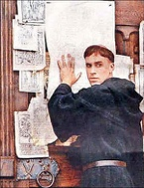Define **indulgences**: _______________________________________________________________

* 1. What did this monk write in 1517 to hand out throughout Western Europe? ___________________
  2. He was *excommunicated* from the church and went into hiding, where he translated the Bible from ____________________ to ____________________ so that literate Germans could read it (and therefore challenge the practices of the Roman Catholic Church for the first time in history).

1. **Spotlight on Culture:** Who invented the printing press around 1450? _____________________________
2. What were Luther’s followers called? _____________________________
   1. Why did this group of Luther’s followers push for greater education for more Europeans to be able to read? _________________________________________________________________________

* This led to the Bible being translated into the many languages of Western Europe.

1. The Roman Catholic Church launched its own movement called the **Counter Reformation**, which led to the following:
   1. The church stopped selling what? _______________________________________
   2. Which new religious order was created? ___________________________________ (or **Jesuits)**