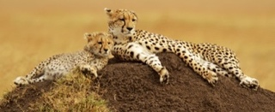
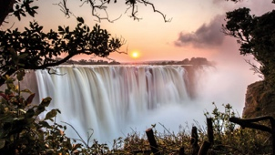
Name: _____________________________________ Period: __________ Date: __________________________
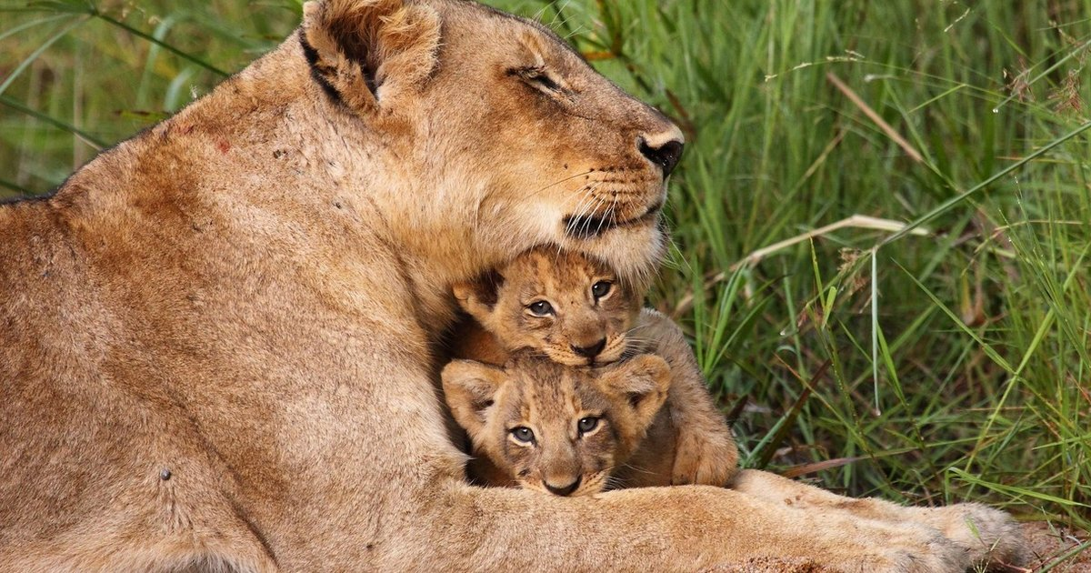
Africa

I. Early States and Trade, pp.372-373
1. Looking at the box at the top of the page, what’s the Main Idea of this section? _________________________ _________________________________________________________________________________________
2. What is trans-Saharan trade? ________________________________________________________________
a. Which religion did trans-Saharan trade introduce Africans to? _________________________________
* This religion spread from the Arabian Peninsula beginning in the 8th C.
3. In West Africa, several empires rose to power and thrived because of which two important trade items? 1) ________________________, which was found in _____________________ 2) ________________________, which was found in _____________________
4. How did Ghana gain power and wealth, and therefore come to control West Africa from A.D. 700 to the 1200s? _________________________________________________________________________________________
5. After the decline of Ghana, Mansa Musa made which city a center of education? ________________________
6. On which sea was the trade city of Adulis located (and is in modern-day Ethiopia)? ______________________
7. Which city-state formed on the coast of East Africa as trading grew (and is in modern-day Somalia)? _________________________________________
a. While trans-Saharan trade was important, trade was most prevalent on the east coast of Africa during the time of the explorers because it was closer to India and China.
8. What does the word Zimbabwe mean? _____________________________________
a. Which three metals did the Shona trade with places as far away as China and India? 1) ____________________, 2) ___________________ & 3) ___________________

II. Impact of the Slave Trade, pp.374-375
9. While slavery existed in Africa for many years, describe how someone could become a slave in Africa before European contact: ________________________________________________________________________ _______________________________________________________________________________________
10. What would often happen to the women and children who were taken captive by rival tribes? ____________
_______________________________________________________________________________________
11. Starting in the 700s, Africans began being captured and sold to which two areas?
1) ____________________________ & 2) ______________________________

12. Who were the first Europeans to explore the African coast in the 1400s? ________________________
13. When did the trans-Atlantic slave trade begin? ____________________________________
a. What is meant by trans-Atlantic slave trade? ___________________________________________________
14. List the five countries that purchased slaves at African coastal ports: 1) ________________________, 2) ___________________, 3) ___________________, 4) _________________ & 5) _____________________
15. Using the green box on p.375 or researching it on your iPad, describe the journey and horrible conditions that slaves had to endure as they crossed the Atlantic Ocean on their way to the colonies in the Americas: _________________________________________________________________________________________ _________________________________________________________________________________________ _________________________________________________________________________________________
16. What is this trip that enslaved Africans took across the Atlantic Ocean to colonies referred to as? ________________________________________
a. Approximately how many people died during the trip across the Atlantic? ________________________
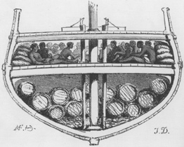
b. What were the two main causes of death during this horrible journey?
1) ___________________________ & 2) ____________________________
17. What were three major crops that were grown on plantations that slave labor was used for? 1)______________________, 2) ____________________ & 3) _____________________
18. The trans-Atlantic slave trade lasted from the ________________ until the mid-________________.
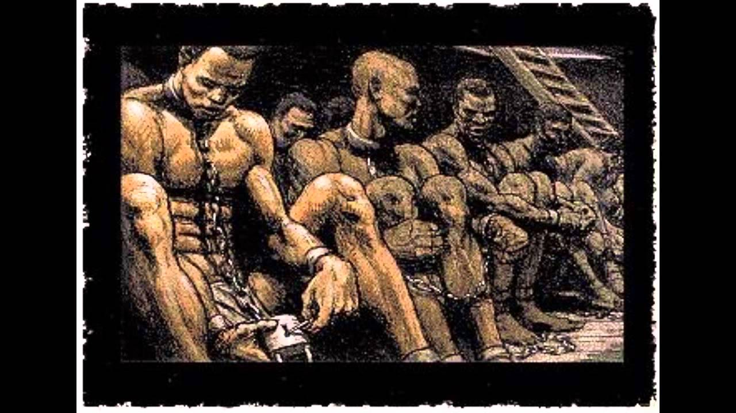 a. Approximately how many slaves were enslaved and shipped to the Western Hemisphere during this
time? ____________________________
19. Which two areas were the majority of slaves sent in the new world?
1) _________________________ & 2) ______________________________
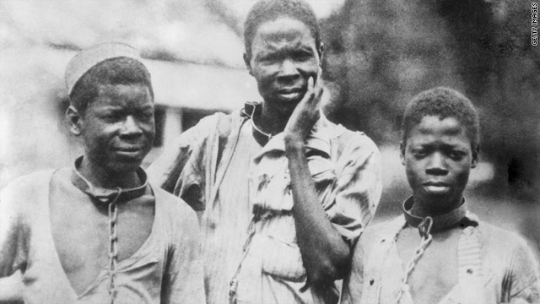20. Looking at the chart of the Middle Passage on p.375, which range of years transported the most enslaved Africans? ______________________________
21. What were two characteristics that those who were forced into slavery generally shared? 1) ________________________________ & 2) ___________________________________
22. What three things did enslaved Africans bring with them that helped shape the culture of the Americas? 1) ___________________________, 2) __________________________ & 3) _________________________

III. Colonization to Independence, pp.376-377
23. What is imperialism? ______________________________________________________________________ _________________________________________________________________________________________
24. What started European imperialism in Africa? __________________________________________________ _______________________________________________________________________________________
a. Europeans then moved into African lands in search of what? _____________________________________ b. Eventually, several European countries conquered African lands and established what? ________________
25. Define colonialism: _______________________________________________________________________ ________________________________________________________________________________________
26. By the mid-1800s, European countries began fighting over their African colonies because of the many natural resources that helped fuel what in Europe? ______________________________________________________
27. Why were Africans unable to stop the Europeans from controlling and settling their lands? _________________________________
28. What was the purpose of the Berlin Conference in 1884? _________________________________________ _______________________________________________________________________________________
a. While no Africans were invited to attend, what happened as a result of the Berlin Conference? ____________________________________________________________________________________
b. Which 6 European countries established themselves as colonial powers in Africa by 1910? 1) ______________________________ 4) _________________________________
2) ______________________________ 5) _________________________________
3) ______________________________ 6) _________________________________

29. Europeans sent missionaries to Africa to do what? _______________________________________________
30. The Organization of African Unity (OAU) was created in 1963 to promote Pan-Africanism (the movement to promote unity and cooperation among African people). What is this organization known as today? _______________________________________________________________________________________
*This organization also functions as an economic group similar to the European Union (or E.U.).
31. Looking at the map on p.377 of the European colonies in 1938, which two European countries had colonized Africa the most at the time? 1) __________________________ & 2) ____________________________

IV. Ending Apartheid, pp.402-403
32. What year did South Africa become a democracy, marking the end of racial segregation? _________________
33. Which two European countries laid claim to South Africa in the 19th century? 1) ____________________________ & 2) ____________________________
34. What was the name of the new laws that passed in 1948 that legally separated the races? __________________
35. Which group was formed (and later outlawed) to protest the unfair treatment of native Africans? ________________________________________________________
a. Which leader of this group was imprisoned? ____________________________________
b. What year was this civil rights leader released from prison? ________________________
c. What would this leader later become? _________________________________
