Name: _____________________________________ Period: _______ Date: ___________________________

Rain Forests and Climate Change, pp.198-199

1. Looking at the top of the page, what is the Main Idea of this section? _______________________________ _______________________________________________________________________________________

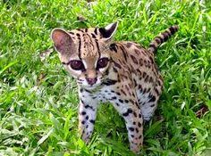2. Rain forests are complex ecosystems, which means they are home to thousands of what?
1) ___________________, 2) __________________ & 3) ____________________

3. What are two of the diseases that plants from the rainforest can cure?
1) ____________________________ & 2) ____________________________
For additional plants and the diseases they cure, click on the following link from my website:
https://www.rainforestcruises.com/jungle-blog/top-10-medicinal-plants-of-the-amazon

4. What is transpiration? ___________________________________________________________________
*We’ll be watching a clip from Planet Earth II – Jungles to see how transpiration works, as seen below.

5. The process of transpiration below shows how plants in the Amazon produce their own rain:

Clouds produce _______________

Vapor cools & forms ___________ warm air + moist soil = growth of _______________________
(high, thick trees block sunlight from forest floor)

Plants & trees release ________________________ into air

6. What do the plants of the Amazon absorb from the atmosphere? ___________________________________
a) Define greenhouse gas: ______________________________________________________________
b) What produces greenhouse gases? _____________________________________________________
c) Give an example of a greenhouse gas: ___________________________________
d) Why does having too much carbon dioxide in the air cause the atmosphere to warm? _____________ _________________________________________________________________________________
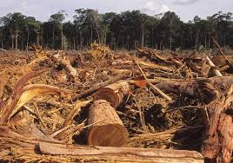
7. How much of the rain forest has been lost in last 40 years? ___________
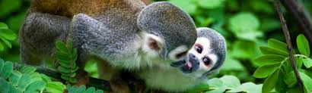
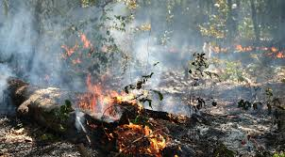

8. Using your iPad to research, what are the major effects of widespread deforestation in the Amazon?
a. On the environment: ____________________________________________________________________ ______________________________________________________________________________________
b. On animals: ___________________________________________________________________________ ______________________________________________________________________________________
A Global Climate Challenge
9. What is climate change? ___________________________________________________________________ _______________________________________________________________________________________
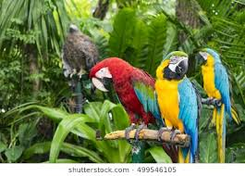 10. What is global warming? _____________________________________________________ __________________________________________________________________________

11. How much has the average temperature of globe risen since the beginning of 20th century?
____________ a. A change of how many degrees is cause for concern? ______________

12. What two effects do rapid changes in average temperature cause? 1) __________________________ &
2) ______________________________
Reflection Questions:
13. Why are rain forests important? _____________________________________________________________ _______________________________________________________________________________________

14. What is the difference between climate change and global warming? _______________________________ _______________________________________________________________________________________ _______________________________________________________________________________________

15. According to the graph on page 198, what has been the general trend in deforestation since 2004? What do you think caused this trend? ________________________________________________________________ _______________________________________________________________________________________ _______________________________________________________________________________________

Rain Forest Art: On your iPad, research plants and animals found in the Amazon rain forest. Pick your favorites, write the names in the blanks, and then sketch both below to the best of your ability. You are encouraged to show your hard work to your classmates.

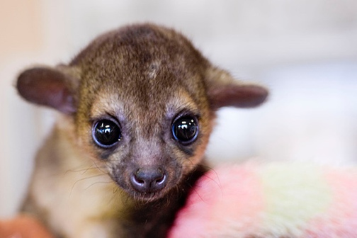

16. Plant Name: _________________________ Drawing of plant

17. Animal Name: ________________________
Drawing of animal

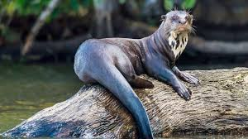Read about the Amazon River on pp.194-195 and answer the following questions:

18. Where does the Amazon River begin? ______________________________________
a. How many miles does it flow? __________________________

19. Define tributary: _______________________________________________________________________
a. How many tributaries does the Amazon River have? _____________________
* Seven of these tributaries are more than 1,000 miles long.
20. Though the Amazon River is the world’s __________________________________, it is the largest river in terms of what? ____________________________
21. Define biodiversity: ______________________________________________________
a. Using your iPad, list some of animals found in and around the Amazon River: ______________________
_____________________________________________________________________________________
22. In what ways is the Amazon rain forest being threatened nowadays? 1) _____________________________, 2) _________________, 3) _________________, 4) ________________ & 5) ________________________
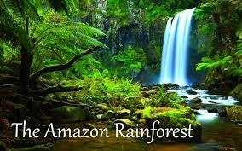

Read about the Inca on pp.200-201 and answer the following questions:

23. Along which ocean did the Inca Empire stretch? ____________________________
a. In which mountain range did the Inca build their empire? ________________________
24. Which 6 present-day countries were part of the Inca Empire? 1) ________________, 2) _______________, 3) _______________, 4) __________________, 5) ________________ & 6) ________________________
25. The Inca was South America’s largest and most advanced civilization from the year _______until ________
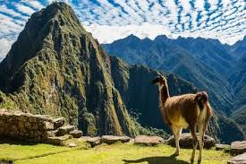 a. Who overthrew the Inca? _______________________

26. What was the capital of the Inca Empire? __________________
a. In which country is the Incan capital located? _____________________
27. Which god did the Inca believe their emperor, the Sapa Inca, was a descendant of? ____________________
28. Achievements of the Inca:
1) Farmed on ______________________________, or flat fields cut into slopes or mountainsides
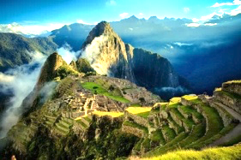
2) What did the Inca build to water their crops? _________________________
3) What did they build to cross canyons or rivers? __________________________
4) What did they build that helped keep the empire unified? _____________________
* Fun fact: The Inca Trail can still be hiked today and is a popular tourist attraction.

5) Which famous Incan city was built on a mountain in the 1400s? ___________________________
29. What two factors led to the Inca defeat? 1) __________________________ & 2) _____________________

30. Who are the descendants of the Inca today? ____________________________________

