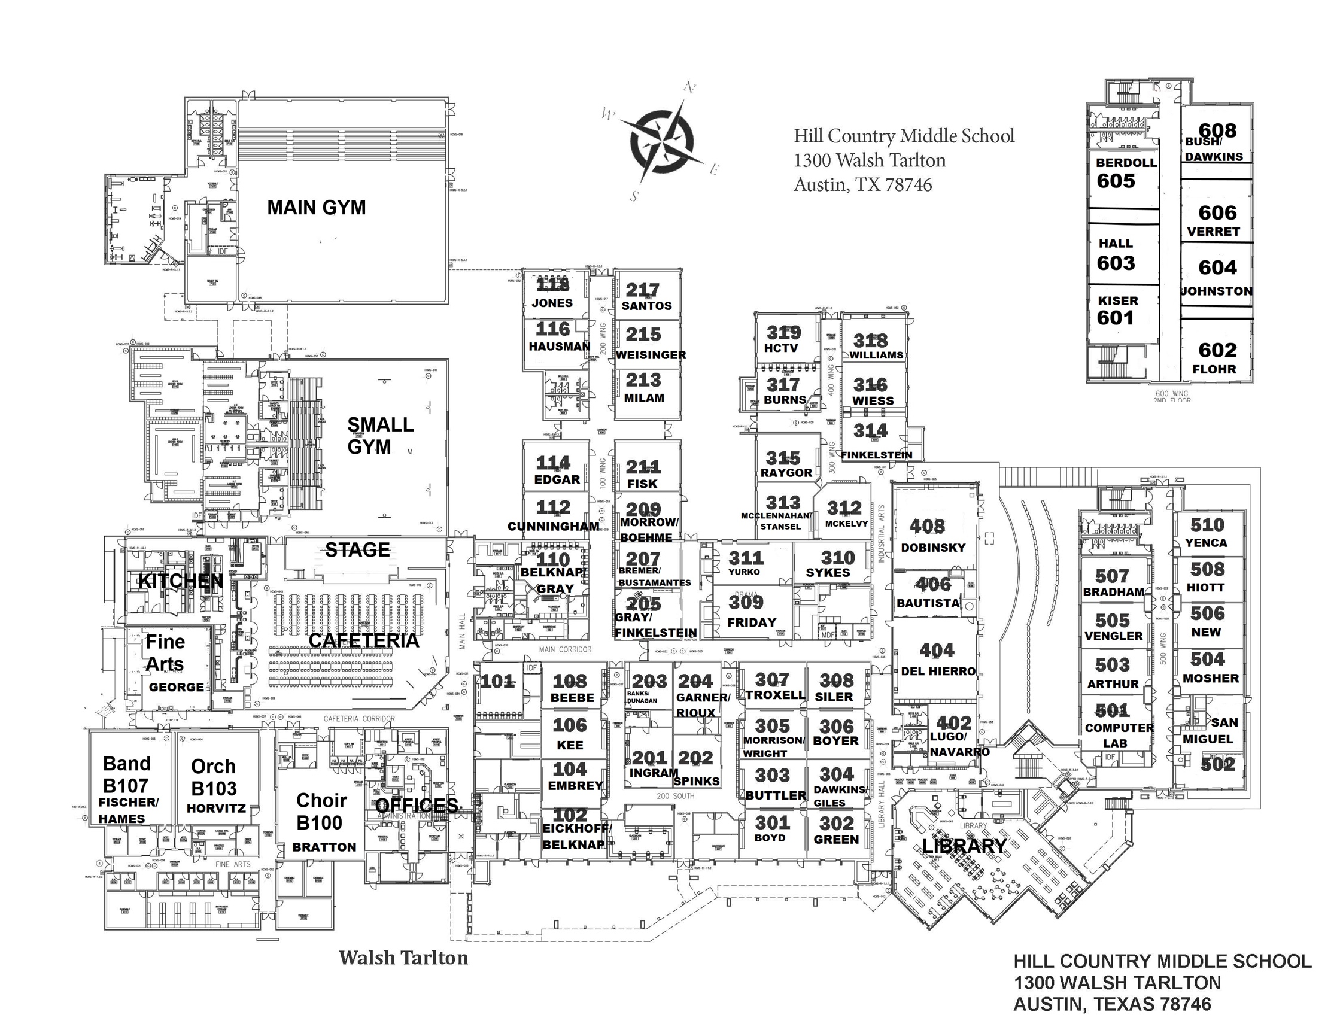

**Back to School Night Legend/Key** – Parents, please use this map to navigate to each of your child’s classes and teachers.

Color/symbol Subject – Teacher Color/symbol Subject – Teacher

1st - ___________ __________________________________ 5th - ___________ ______________________________________

2nd - ___________ __________________________________ 6th - ___________ ______________________________________

3rd - ___________ __________________________________ 8th - ___________ ______________________________________

4th - ___________ __________________________________ **\*Please note:** 7th period is advisory – please go directly from 6th to 8th period.

11118

118

**Final Draft**