Name: ____________________________________________________ Period: _________ Date: ____________________________
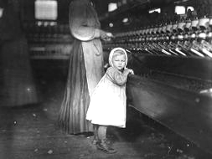
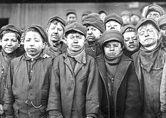

BBC Documentary: The Children Who Built Victorian Britain

1. As the documentary plays, list the various reasons children of the Industrial Revolution were referred to as “the white slaves of England”:

_____________________________________________________________________________________________________________
_____________________________________________________________________________________________________________

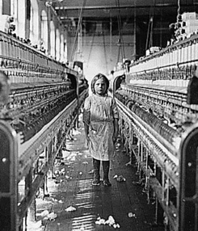
Children Working in Factories:
2. What were some of things children were promised (but did not actually get) to lure them into working in factories?

____________________________________________________________________________________________
____________________________________________________________________________________________
a. In reality, what were some of the horrible conditions kids actually faced in the factories?
__________________________________________________________________________________________________________
__________________________________________________________________________________________________________
__________________________________________________________________________________________________________
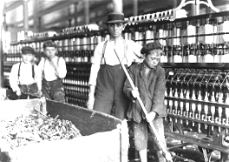
3. Which group of kids were the most targeted to work in factories? __________________________________________

4. What happened to Charlotte Smith & Esther Price for trying to escape? _______________________________________________________________________________________________
_______________________________________________________________________________________________
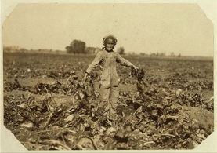
_______________________________________________________________________________________________

Children Working on Farms:
5. At what young age could children be sent to work on farms? _____________________________
a. What job was William Arnold given on this farm? ____________________________________________
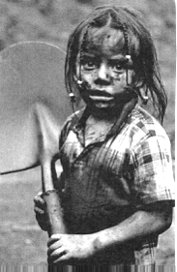
b. What were some of the horrible conditions of working in agriculture?
_______________________________________________________________________________________________
_______________________________________________________________________________________________
_______________________________________________________________________________________________
Children Working as Chimney Sweeps:
6. What were some of the horrific conditions that children faced as chimney sweeps? ________________________
_____________________________________________________________________________________________________________
_____________________________________________________________________________________________________________
_____________________________________________________________________________________________________________
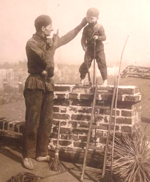
7. Why were children used to clean chimneys rather than chimney brushes? ____________________
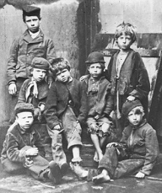
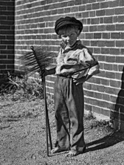
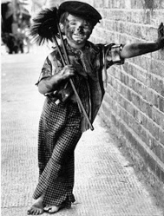
_________________________________________________________________________________________________
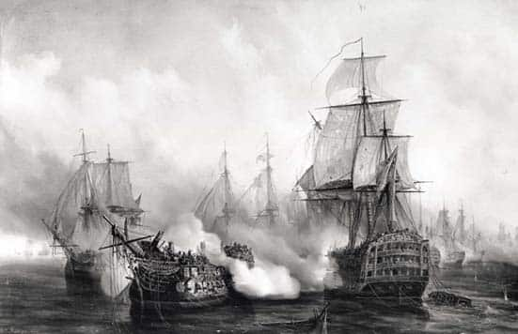
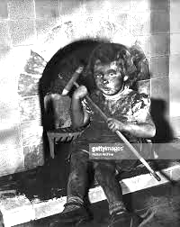

Children in the War:
8. How old was the youngest kid to be sent to war? ___________________________
a. Why were kids sent to war during the Industrial Revolution? ____________________________________________
___________________________________________________________________________________________________________
9. What were some of the traumatic experiences kids endured while on the navy ships? ______________________
_____________________________________________________________________________________________________________
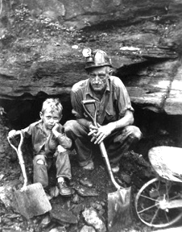
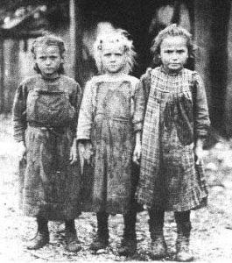
_____________________________________________________________________________________________________________
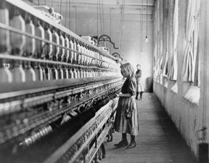

Additional resources to independently research – please access from my website:
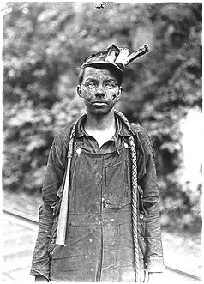
- Informative website about various injustices towards children during the Industrial Revolution: https://childlaborindustrialrevolutionn.weebly.com/injuries-among-children.html
- Additional stories about the mistreatment of child laborers: https://spartacus-educational.com/IRpunishments.htm
- Ducksters – What kinds of jobs did children do during the Industrial Revolution? https://www.ducksters.com/history/us_1800s/child_labor_industrial_revolution.php
- The 1833 Factory Act (to “improve” working conditions for children in factories): http://www.nationalarchives.gov.uk/education/resources/1833-factory-act/
- History.com – Child Labor: https://www.history.com/topics/industrial-revolution/child-labor

