Name: __________________________________________ Period: __________ Date: ____________________________________

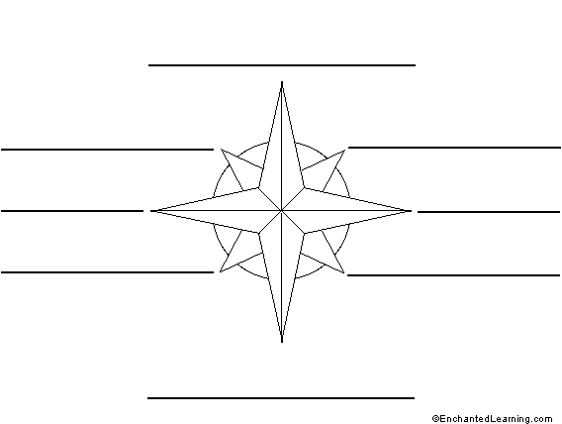
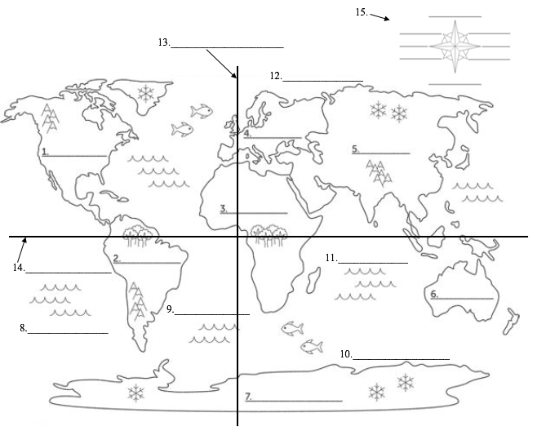
World Map: Using the atlas in your textbook and/or your iPad, please label the 7 continents, 5 oceans, equator, prime meridian, and the cardinal and intermediate directions on the compass rose.

