Name: ________________________ Period: _____________ Date: _________________

Maps: “How do people use geography?”

Read pp.18-27 in your textbook. Use the key words & page numbers on the left-hand side to guide you.
Main Idea, p.18 | - What are two different tools used to study places on Earth?  1) _______________________  2) _______________________
Globes & Maps, p.18 | Define the following terms:  - Globe: _________________________________________________________________  - Map: __________________________________________________________________
Map & Globe Elements, p.18 | Answer the following questions about the various elements of both maps and globes:  4. What does a title tell you? __________________________________________________
5. What do the symbols represent? ______________________________________________ _______________________________________________________________________

6. What are labels? __________________________________________________________ _______________________________________________________________________
 | 7. What do colors do? _______________________________________ (i.e. water = blue)
 | 8. What are latitude lines? ____________________________________________________ _______________________________________________________________________
 | 9. What are longitude lines? __________________________________________________ _______________________________________________________________________
 | 10. What does a scale show? __________________________________________________ _______________________________________________________________________
11. What purpose does the legend/key serve? ____________________________________ _______________________________________________________________________

12. What does a compass rose show? ___________________________________________ _______________________________________________________________________

Latitude Lines, p.19 | 13. Lines of latitude run ____________ to ____________, but measure distances north  and south of the ________________________ (which is 0° latitude).  Lines of latitude run  *Hausman’s helpful hint: “Latitude is ___________________________.”  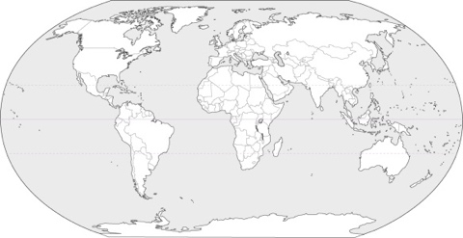  14. Please complete the following on the map to the right:  - Label the equator  - Draw a line of latitude…  - north of the equator  - south of the equator  *Note: There are 90° north of the equator and 90° south of the equator.
Longitude Lines, p.19 | 15. Lines of longitude run ___________ to ___________, but measure distance east or  west of the _____________________________________ (which is 0° longitude and runs through Greenwich, England).  *Lines of longitude run  16. There are how many degrees…  a) east of the prime meridian? _________________ *Reflect: How many degrees  b) west of the prime meridian? _________________ are in a full circle?  17. The exact point where a place is located is called the __________________________  (i.e. Berlin, Germany is located at 52° North of the equator & 13° East of the prime meridian (or 52° latitude & 13° longitude))  18. Please complete the following on the map to the right:  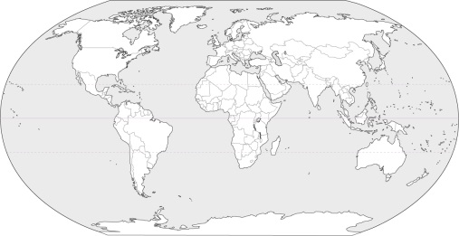  - Label the prime meridian  - Draw a line of longitude…  - east of the prime meridian  - west of the prime meridian
Hemispheres, p.19 | 19. What does the word hemisphere mean? _____________________________________  20. Label the Northern Hemisphere and Southern Hemisphere directly below:  1) ________________________________  2) ________________________________  *  21. Label the Eastern Hemisphere and Western Hemisphere directly below:  *Reflect: What are the  hemispheres divided by?  1) ___________________________ 2) ___________________________  *Please note: This is why the U.S. is referred to as Western Civilization.
Map Scale, p.20-21 | 22. A map’s scale shows how much ________________________________ is shown on  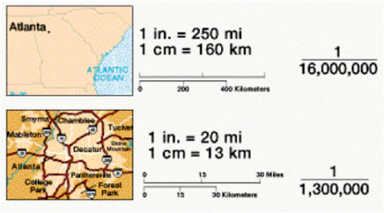  the map.
Political & Physical Maps, pp.22-23 | 23. What kinds of features do political maps show? ________________________________ ___________________________________________________________________________  *Examples of political map features: _____________________________________________  24. What kinds of features do physical maps show? ________________________________ ___________________________________________________________________________  *Examples of physical map features: ____________________________________________  25. Label the maps below – political or physical:  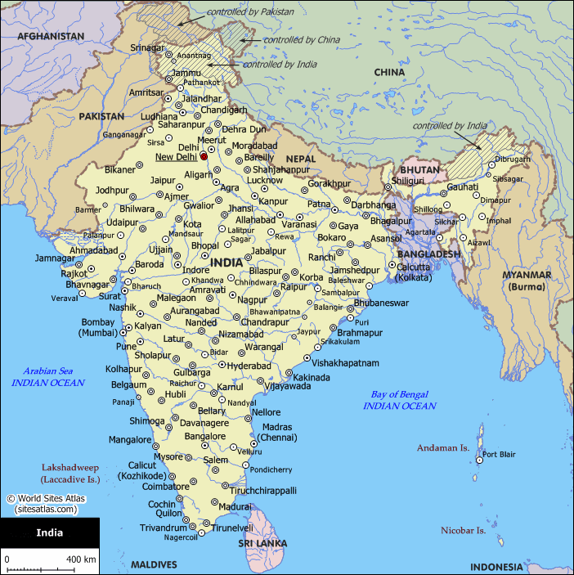  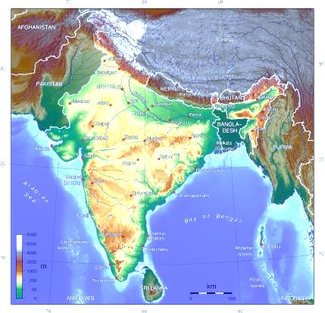  1) _____________________ 2) ____________________
Map Projections, pp.24-25 | 26. What do projections show? _________________________________________________  _______________________________________________________________________
Types of Projections, pp.24-25:  *Please draw the 4 types of projections in the boxes to the right, and fill in the brief description below each.  Note: You do NOT need to draw perfect continents or label each latitude & longitude line. | 27. Azimuthal: 28. Mercator:  *Often used for ____________________ *Good for ____________________________  29. Homolosine: 30. Robinson:  *Accurately shows __________________ *Most common; shows shapes and area of  ___________________________________ continents and oceans fairly accurately.

