Name: _______________________________________ Period: __________ Date: _______________________
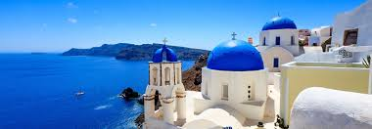
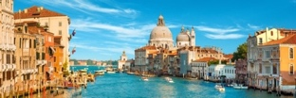

Europe Daily Geography

Please use the following resources to answer the questions below about Europe’s political and physical features: 1) A18-22 in your textbook, 2) the maps posted on Google Classroom & 3) your iPad to research

1. Which mountain range separates the European and Asian sides of Russia? _____________________________

2. List the two oceans that border Europe: 1) _________________________ & 2) ________________________

3. List three (out of the 5) countries in Europe that are island nations:
1) ___________________________, 2) ___________________________ & 3) _________________________

4. Which river flows into the Caspian Sea and is the longest river in Europe? _____________________________

5. On which peninsula are Norway and Sweden? ____________________________________________________

6. Which mountain range borders Austria, France, Germany, Italy, and Switzerland? _______________________

7. Which body of water separates France and England? ____________________________________________

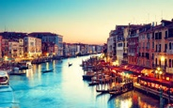
8. Which country is a boot-shaped peninsula that is bordered by the Mediterranean and Adriatic Seas?

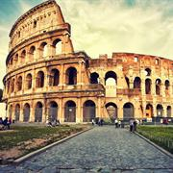
________________________________

9. Which two countries are located entirely on the Iberian Peninsula?
1) _______________________________ & 2) _______________________________

10. Which ocean borders Russia, Iceland, and Norway? ____________________________________________

11. List three (out of the 9) countries that border the Baltic Sea:

1) ___________________________, 2) __________________________ & 3) _________________________

12. What is the difference between Great Britain and the United Kingdom?
a. Great Britain is made up of which 3 countries?
1) _________________________, 2) _________________________ & 3) _________________________

b. The U.K. includes the above 3 countries and which other region? _________________________________

14. What is the largest country in Europe (and in the world)? ___________________________________

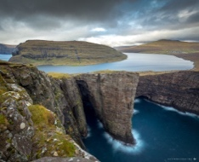
15. Gibraltar, which is located on the Iberian Peninsula and is known for shipping and trade, is a territory of which other country? __________________________________

16. Which mountains run through Andorra, and form the border between France and Spain?
_________________________________________

17. Which archipelago is a territory of Denmark? _________________________________

