Religion | Hinduism | Buddhism | Christianity | Islam | Sikhism
Year(s) established | c. 2500-1500 B.C. | 520 B.C. | 33 A.D. | 622 A.D. | 1400s A.D.
Founder |  | (prince) | (founders of Christian church) | (Prophet) | Guru Nanak  (combination of Hinduism & Islam)
Number of Followers & Size | 1 billion (3rd largest) | 376 million (4th largest) | 2.2 billion (1st largest) | 1.6 billion (2nd largest) | 23 million (5th largest)
Holy Book(s) | (Books of Knowledge) |  | (Bible)
Language(s) of Holy Book(s) |  |  |  |  | Punjabi
Core Beliefs | Karma & reincarnation; the 5 principles & 10 Disciplines | The 4 Noble Truths &  Eightfold Path | Accept Jesus as the son of God & Baptism |  | Karma & reincarnation; truthful living & equality
Holy Cities / Places | Varanasi, India & Tirthas (pilgrimage centers) | Nepal: Lumbini  India: Bodh Gaya, Sarnath & Kusinara |  | Jerusalem, Mecca & Medina | Amritsar, India  (the Golden Temple)
Religious Symbol(s) | 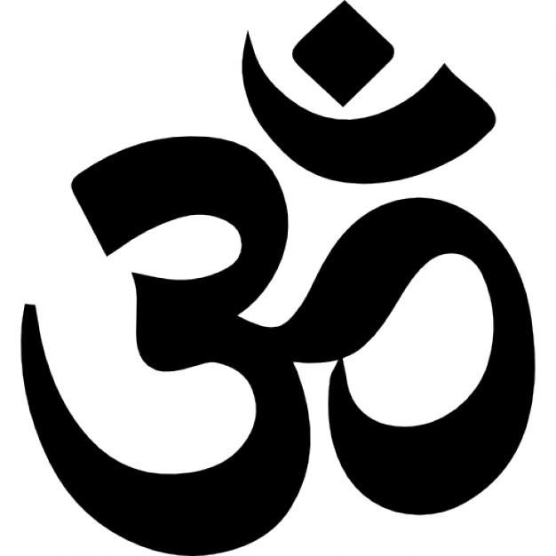 | 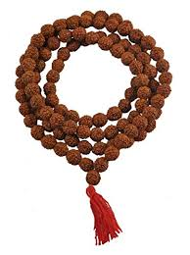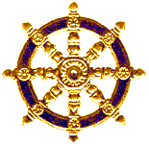 | 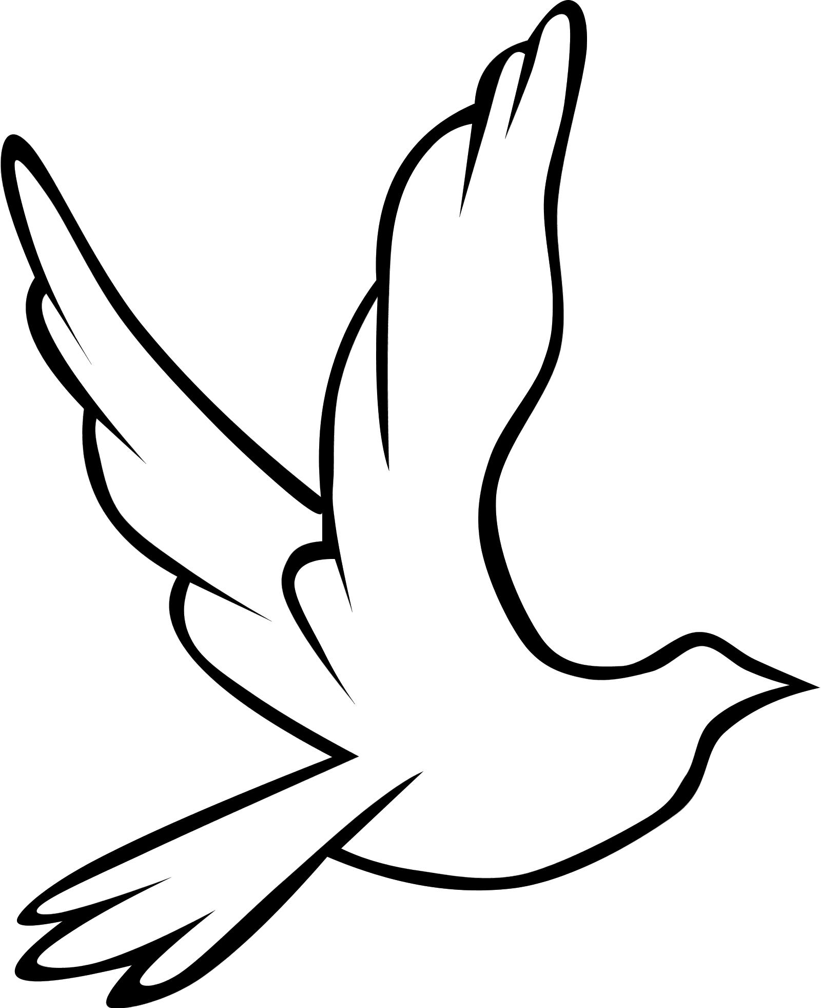 |  | 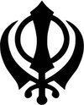
Monotheistic or Polytheistic |  |  |  |  | Monotheistic
Name of Deity / Deities | Brahma (creator), Shiva (destroyer) & Vishnu (preserver) |  | God, Jehovah (Latin),  Jesus Christ (Messiah) | Allah (in Arabic) | Waheguru  Translation: “Wonderful teacher”
Place(s) of Worship | Temple or home shrine | Temple or meditation hall | Church, Cathedral, Chapel, Temple or Basilica | Mosque | Gurdwara (“gateway to the guru”)
Religious Leaders |  |  | Priest, Preacher, Pastor, Minister, Reverend, Pope, etc. | Sheikh (Sunni) & Imam (Shia)
Holy Day of Week (or Sabbath – day of rest) | None – personal meditation daily | None – personal meditation daily |  |  | Many Sikhs visit a Gurdwara daily
Holidays (Holy Days) | Diwali – Festival of Lights  Holi - Festival of Colors | Buddha Day & Buddha's Enlightenment | Christmas, Good Friday & Easter | Ramadan, Eid al-Adha &  Eid al-Fitr | Birthdays of gurus, Sikh New Year, Diwali & Holi Festival
Goal or Purpose | Moksha: | Escaping the cycle of rebirth to attain “Nirvana” | Know, love & serve God | To attain paradise after death | To escape cycle of reincarnation in order to become one with God
