Name: _______________________________________ Period: __________ Date: _____________________
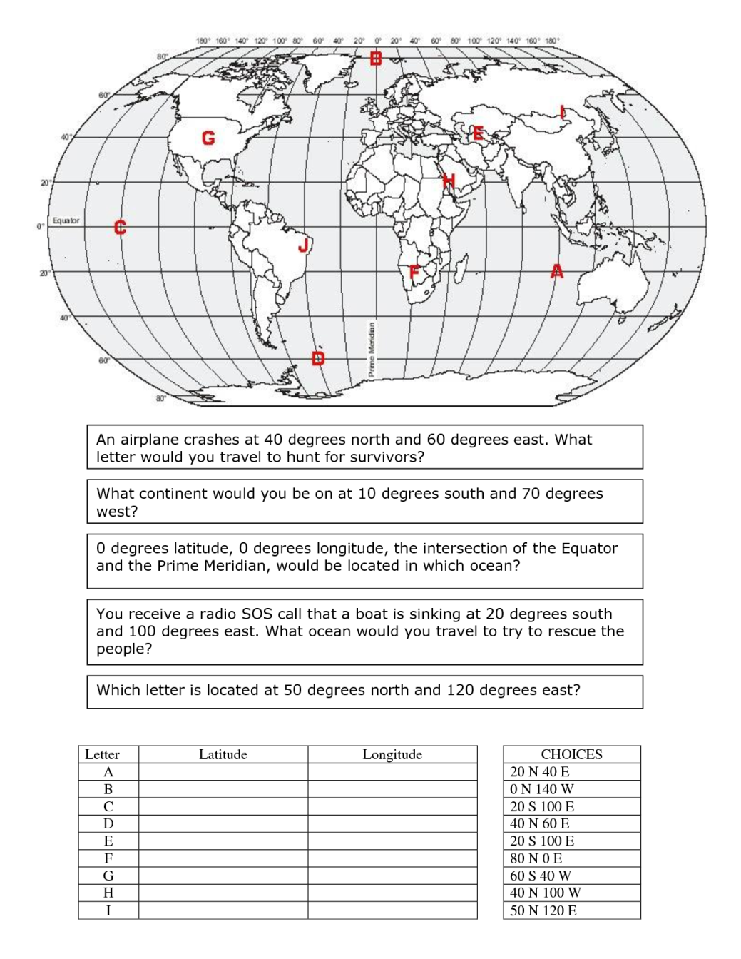
To find the absolute location: 1) How many degrees North or South of the Equator (latitude)? 2) How many degrees East or West of the Prime Meridian (longitude)?

: N / S
: E / W
20° N 40° E
40° N 60° E
0° 140° W
20° S 100° E
80° N 0°
60° S 40° W
40° N 100° W
50° N 120° E
20° S 20° E
II. Find the letters A-I on the world map above and then write the coordinates for each using latitude (N/S) and longitude (E/W).

°
20 E

