**Instructions for Countries of South America Presentation**

Explore and learn about South America through the 5 Strands of Social Studies! In groups of 2-3, you will be researching and teaching your classmates about the South American country that your group chose. Using the app of your choice, your group will create an *interesting* and *informative* presentation that fulfills each of the requirements outlined below. This is an in-class project, so please use your time wisely to prevent it from becoming homework and honor your commitment to your group by contributing equally.

**For each of your facts:** You MUST include specific names of people, places, and things, as well as clarifying details that adds fun and interesting information. Also, include pictures that relate to your facts so that your audience connects with the information that they are learning (like native animals, landforms, landmarks, etc.).

**Please use the following outline to complete your presentation – choose 4 categories under each of the 5 strands:**



1. **Title: [Your South American country] + the information below:**



* + Group members’ first and last name
  + Your class period
  + An awesome picture (or pictures) from your country

1. **Title: History + 4 bulleted facts about your country’s history, with clarifying details & pictures:**
   * **History:** Indigenous people, discovery of, settlement, (civil) wars, revolutions, gaining its independence, diseases/epidemics, natural disasters, and any major event, past to present
   * **Famous & infamous people:** Actors, singers, athletes, models, leaders, politicians, revolutionaries, etc.
2. **Title: Geography + 4 bulleted facts about your country’s geography, with clarifying details & pictures:**
   * **Major landforms:** Mountains, volcanoes, deserts, rain forests, islands, canyons, caves, reefs, etc.

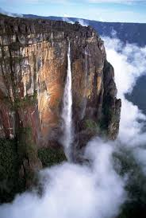

* + **Bodies of water:** Rivers, lakes, waterfalls, seas, oceans, bays, straits, etc.
  + **Famous landmarks:** Ancient cities, settlements, bridges, monuments, museums, buildings, etc.
  + 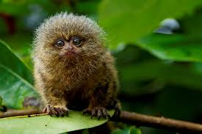**Native animals:** Mammals, birds, fish, reptiles, and amphibians
  + **Native plants**
  + **Human-environment interaction:** How humans change or enjoy the environment

1. **Title: Culture + 4 bulleted facts about your country’s culture, with clarifying details & pictures:**
   * **Forms of entertainment:** Sports teams, style of dance, music, games, etc.
   * **Unique foods:** Native dishes and delicatessens (plants, animals, and/or insects)
   * **Unique festivals & holidays**: Each country will have holidays not celebrated in the U.S.
   * **Customs, traditions, and/or cultural beliefs:** Of indigenous people or in your country
   * **Greetings in your country**: Verbal and/or physical greetings that are different from ours
2. **Title: Government + 4 bulleted facts about your country’s government, with clarifying details & pictures:** 
   * **Capital city:** Please include the name and any random, fun facts about it
   * **Type of government:** Provide the name and a brief explanation of the type of government
   * **Current leader:** Name, title, and any fascinating information about this leader
   * **Laws:** Are there any interesting or unusual laws in your country?
3. **Title: Economics + 4 bulleted facts about your country’s economy, clarifying details & pictures:**
   * **Popular tourist destinations:** Tourism brings in revenue, which helps increase a country’s GDP
   * **Natural resources:** What is your country known for producing?

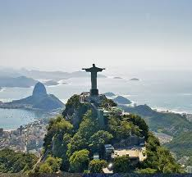

* + **Agriculture:** Crops and livestock
  + **GDP** (Gross Domestic Product) **& GDP per capita** (per person)
  + **Trade:** Major trade cities, ports, and routes (and any fun background information)
  + **Name of currency**

1. **Title: Works Cited + 4-5 websites used for your research & an awesome picture:**
   * Please copy & paste each website you use for your research as you go

Name: _____________________________________________________ Country: _________________________________________

Partner(s): __________________________________________________ Presentation due date: ______________________________

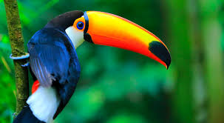

**Rubric for the South America Project**

|  |  |  |  |  |  |  |
| --- | --- | --- | --- | --- | --- | --- |
| **Requirements** | **1 picture**  **per slide *minimum*** | **4 facts per slide**   * **Complete sentences** * **Bullets (3 points/fact)** | **Title on each slide** | **Student checklist – check each as you complete** | **Teacher comments** | **Total**  **Points Earned** |
| **Intro slide: – Country – Group names – Class period** | ____/2 points | ____/4 points | ___/1 point |  |  | _____/7 points |
| **History** | ____/2 points | ____/12 points | ___/1 point |  |  | _____/15 points |
| **Geography** | ____/2 points | ____/12 points | ___/1 point |  |  | _____/15 points |
| **Culture** | ____/2 points | ____/12 points | ___/1 point |  |  | _____/15 points |
| **Government** | ____/2 points | ____/12 points | ___/1 point |  |  | _____/15 points |
| **Economics** | ____/2 points | ____/12 points | ___/1 point |  |  | _____/15 points |
| **Works Cited** | ____/2 points | _____/5 points | ___/1 point | **4-5 websites?** |  | _____/8 points |
| **Proper English, Neatness & Creativity** |  | | |  |  | _____/10 points |
| **Total (major) grade:** | | | | | | _______/100 points |

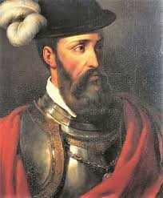

**Helpful tips on how to make your presentation stand out:**

* Avoid white backgrounds – people naturally enjoy pictures and color (or dark backgrounds).
* Make sure to include *clarifying details* to your facts, which make your facts a lot more interesting.

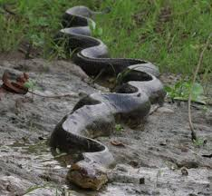

**Example 1:** The capital of Peru is Lima, *which was founded in 1535 by the Spanish conquistador, Francisco Pizarro*.

**Example 2:** Brazil has both the Amazon River and Rainforest, *which is home to 30% of the world’s plants and animals, such as piranhas, anacondas, black caimans, bull sharks, giant otters, and river dolphins*.

*To find fun clarifying details, enter “interesting facts about [specific person, place, or thing]”

**Examples:** Interesting facts about Lima; interesting facts about the Amazon

* Like the ones above, include small pictures that relate to your facts to show your classmates what the people, places, animals, and things look like in your country – it makes your presentation so much more meaningful!
* Make sure your font colors and size are easy to read & that your titles and information fit on the slide when in presentation mode (by putting it in presentation mode *before* you get in front of the class to present). ☺