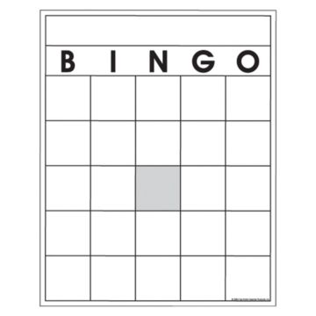

**Write your choice of 24 countries in any order in the boxes on your BINGO board. Make sure to fill up all the squares and use each country only once. You may use the margins or a separate piece of paper to write down the coordinates as they are called. Put an X or check in each box after the country’s coordinates are called.**

**\*Remember: The first coordinate: North or South of the Equator; the second coordinate: East or West of the Prime Meridian**

|  |  |  |  |
| --- | --- | --- | --- |
| 1. **Afghanistan**: 34°N, 68°E | 1. **Ecuador**: 0°, 78°W | 1. **Madagascar**: 15°S, 45°E | 1. **Spain**: 40°N, 4°W |
| 1. **Algeria**: 28°N, 2°E | 1. **Egypt**: 27°N, 31°E | 1. **Mexico**: 23°N, 105°W | 1. **Sweden**: 60°N, 15°E |
| 1. **Angola:** 9° S, 13° E | 1. **France**: 46°N, 2°E | 1. **Mongolia**: 45°N, 105°E | 1. **Turkey**: 40°N, 30°E |
| 1. **Antarctica:** 90°S, 0° | 1. **Germany**: 51°N, 10°E | 1. **Morocco**: 30°N, 7°W | 1. **Ukraine**: 49°N, 32°E |
| 1. **Argentina**: 38°S, 64°W | 1. **Greenland**: 72°N, 43°W | 1. **New Zealand**: 45°S, 174°E | 1. **United Kingdom**: 55°N, 0° |
| 1. **Australia**: 25°S, 134°E | 1. **Iceland**: 65°N, 18°W | 1. **Norway**: 60°N, 8°E | 1. **United States**: 40°N, 90°W |
| 1. **Bangladesh:** 24 N, 90° E | 1. **India**: 21°N, 78°E | 1. **Peru**: 9°S, 75°W | 1. **Venezuela**: 10°N, 67°W |
| 1. **Brazil**: 14°S, 52°W | 1. **Indonesia**: 0°, 114°E | 1. **Philippines:** 15°N, 120°E |  |
| 1. **Cambodia:** 12° N, 105°E | 1. **Iran**: 32°N, 53°E | 1. **Peru**: 9°S, 75°W |  |
| 1. **China**: 36°N, 104°E | 1. **Italy**: 42°N, 13°E | 1. **Russia**: 60°N, 90°E |  |
| 1. **Canada**: 56°N, 106°W | 1. **Japan**: 36°N, 138°E | 1. **Saudi Arabia**: 23°N, 45°E |  |
| 1. **Colombia**: 5°N, 74°W | 1. **Kazakhstan**: 50°N, 75°E | 1. **Somalia: 2°N, 45°E** |  |
| 1. **Cuba**: 22°N, 78°W | 1. **Libya**: 26°N, 17°E | **39. South Africa**: 30°S, 23°E |  |

Absolute Location

**Teacher Key:**

* 24 boxes to fill – the World is a free space
* 46 countries to choose from
* Please use a ruler for the lines of latitude (north or south of the equator).
* Remember, how far North or South of the Equator FIRST,
* THEN how far East or West of the Prime Meridian SECOND.
* I will say each coordinate 3 times. Please keep the answer to yourself to give everyone a chance to process. Please use the margins or a sheet of paper to write down the coordinates as they are called out.

Absolute Location