Absolute Location BINGO
W
E
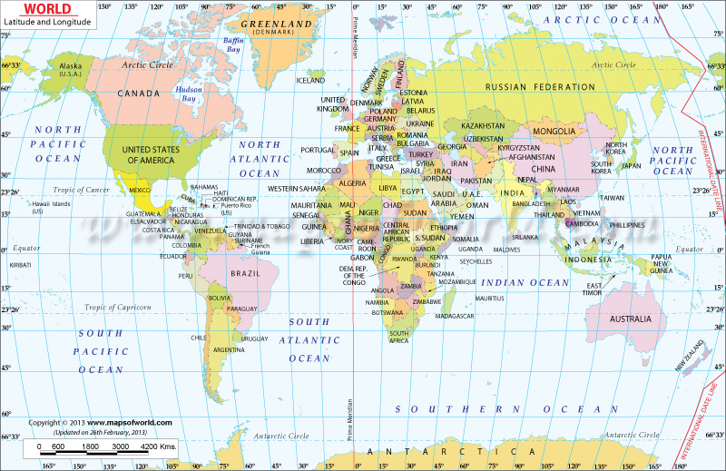
*Remember that coordinates will always list degrees in North or South first, followed by East or West (i.e. 45°N, 90°W).
S
N

