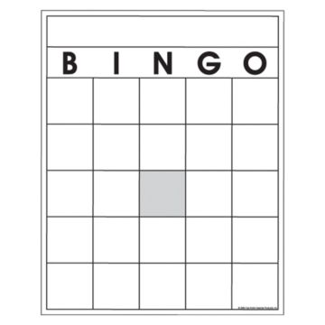
Teacher Key:
Latitude & Longitude

- 25 boxes
- 44 countries to choose from
- “Free” box in the middle
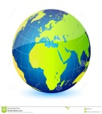
- You may use a ruler to help you find each.
- To help you, think of coordinates as which
hemisphere that country is in (N/S and
then E/W), and the degrees as giving
you the absolute location.
- You may use the extra spaces or a sheet of
paper to write down the coordinates that are called out.
Write the following countries of your choice in the boxes above in any order. Make sure to fill up all the squares and use each country only once. You may use the extra spaces below to write down the coordinates as they are called.
*Remember that coordinates will always list degrees in North or South first, and then East or West (i.e. 38°N, 25°E).

Afghanistan: 34°N, 68°E | Ecuador: 0°, 78°W | Madagascar: 15°S, 45°E | South Africa: 30°S, 23°E | Iceland: 65°N, 18°W
Algeria: 28°N, 2°E | Egypt: 27°N, 31°E | Mexico: 23°N, 105°W | Spain: 40°N, 4°W | Iran: 32°N, 53°E
Argentina: 38°S, 64°W | France: 46°N, 2°E | Mongolia: 45°N, 105°E | Sweden: 60°N, 15°E | Italy: 42°N, 13°E
Australia: 25°S, 134°E | Germany: 51°N, 10°E | Morocco: 30°N, 7°W | United Kingdom: 55°N, 0° | Kazakhstan: 50°N, 75°E
Brazil: 14°S, 52°W | Greenland: 72°N, 43°W | New Zealand: 45°S, 174°E | United States: 40°N, 90°W | Somalia: 2°N, 45°E
Canada: 56°N, 106°W | India: 21°N, 78°E | Norway: 60°N, 8°E | Angola: 9° S, 13° E | Turkey: 40°N, 30°E
China: 36°N, 104°E | Indonesia: 0°, 114°E | Peru: 9°S, 75°W | Antarctica: 90°S, 0° | Ukraine: 49°N, 32°E
Colombia: 5°N, 74°W | Japan: 36°N, 138°E | Russia: 60°N, 90°E | Bangladesh: 24 N, 90° E | Venezuela: 10°N, 67°W
Cuba: 22°N, 78°W | Libya: 26°N, 17°E | Saudi Arabia: 23°N, 45°E | Cambodia: 12° N, 105°E

