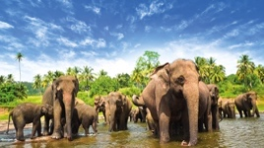
Name: _______________________________________ Period: ____________ Date: ________________________
South Asia: Early Civilizations to Modern Times

I. Early Civilizations – pp. 482-483

1. Which two river valleys were the centers of civilization for the early settlers of South Asia from which ideas spread? 1) ___________________________________ & 2) _____________________________________
2. Which two geographical features limited invasions of the area? 1) _________________________________ & 2) ____________________________
3. The Harappan civilization was the first urban civilization to develop along which river? __________________ a. In modern times, this area is now part of which country? ________________________________________
4. What were the two greatest cities of the Harappan civilization? 1) _________________________________ & 2) ___________________________________
5. Around what year did the Aryans migrate from Central Asia to the Indus Valley? ______________________ a. Which civilization was declining in the area at the same time? ___________________________________ *Reflect: Which leader that we previously studied promoted the Aryan race? _______________________
6. What language did Aryans speak (which became the basis of many modern languages in South Asia)? _________________________________________
7. Please use your physical textbook for this question – the online version has different descriptions.
Aryan society was organized into different social groups called the caste system, which determined a person’s marriage, friendships, education, occupation, etc., and was made up of the following 4 groups:
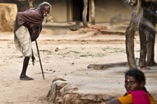
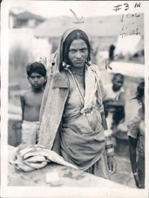
1) Brahmins: ______________________________________________________
2) Kshatriyas: _____________________________________________________
3) Vaisyas: ________________________________________________________ 4) Sudras: _________________________________________________________
There was an unofficial fifth group called the “Untouchables” that performed the lowest jobs in Indian society and were not considered part of the caste system. Many Untouchables migrated out of India and came to be called Gypsies (or Roma), only to face the same severe discrimination and persecution throughout Europe and Asia.
7a. Using your iPad, what were some of the jobs Untouchables had to do? ______________________________________ _________________________________________________________________________________________________

II. Historic Empires – pp. 484-485

8. Which three major religions were spread to South Asia by the Mauryan, Gupta, and Mughal Empires? 1) ___________________________, 2) __________________________ & 3) _________________________
9. Which area did the Mauryan Empire begin in 321 B.C., and later the Gupta Empire in A.D. 321? ________________________________________________________

10. List 3 of the 5 areas that Gupta artists and scientists made lasting advancements: 1) ____________________, 2) _______________________________________ & 3) _________________________________________

11. What was the greatest architectural accomplishment of the Mughal Empire (and is also considered one of
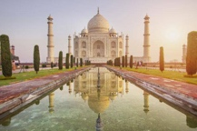
the New Seven Wonders of the World)? _____________________________________________
a. Looking at the timeline on p.485, why was this architectural masterpiece built? _______________
_______________________________________________________________________________

12. What caused the Mughal Empire to come to an end in 1858? ______________________________________ _______________________________________________________________________________________

III. Colonialism to Partition – pp. 488-489
13. What was the name of the British company that traded with countries in East and South Asia, and then later took over parts of India as the Mughal Empire started to decline? ___________________________________

14. Using the glossary in the back of your textbook, define colonialism: ________________________________ _______________________________________________________________________________________

15. What was ONE of the trade practices that Britain put in place that crippled India’s economic growth for more than 100 years? __________________________________________________________________________ _______________________________________________________________________________________

16. While the Indians rebellion against the British was unsuccessful in 1857, it led to the disbandment of the East India Company shortly thereafter. What did Britain do as a result of the East India Company dissolving? _______________________________________________________________________________________

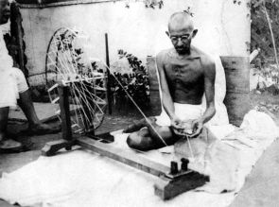
17. Which famous Indian lawyer and activist called for civil disobedience, or nonviolent noncooperation, in the 1930s against the British? ________________________________________
a. What happened to this leader in 1948? _______________________________________

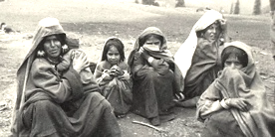
18. As a result of the India Independence Act passed in 1947, British India was divided into two countries (which is known as Partition):
1) Which country was mostly Hindu? _______________________
2) Which country was mostly Muslim? _______________________________
a. What did the east part of this country later become in 1971? ________________________________

19. Due to Partition, tensions between the two countries grew violent. Which area between these two countries caused one of the most violent of conflicts? ____________________________________
a. Why did these countries fight for this area? ___________________________________________________
b. What two things happened as a result of this conflict? 1)________________________________________
& 2) __________________________________________________________
c. What do the countries continue to fight over? _________________________________________________
d. What have both countries threatened to use to “resolve” the dispute? _______________________________

