Name: __________________________________________ Period: _____________ Date: ___________________________________
World Geography Basics
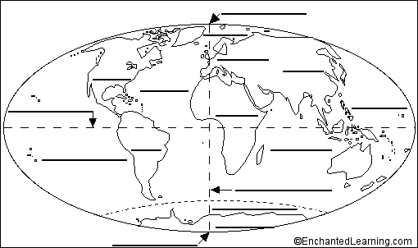
Using a world map, textbook atlas, or iPad, label the 7 continents, 5 oceans, Prime Meridian, and Equator, which are listed below.

* Africa * Australia * South America * Arctic Ocean * Pacific Ocean * Prime Meridian
* Antarctica * Europe * Atlantic Ocean * Southern Ocean * Equator
* Asia * North America * Indian Ocean
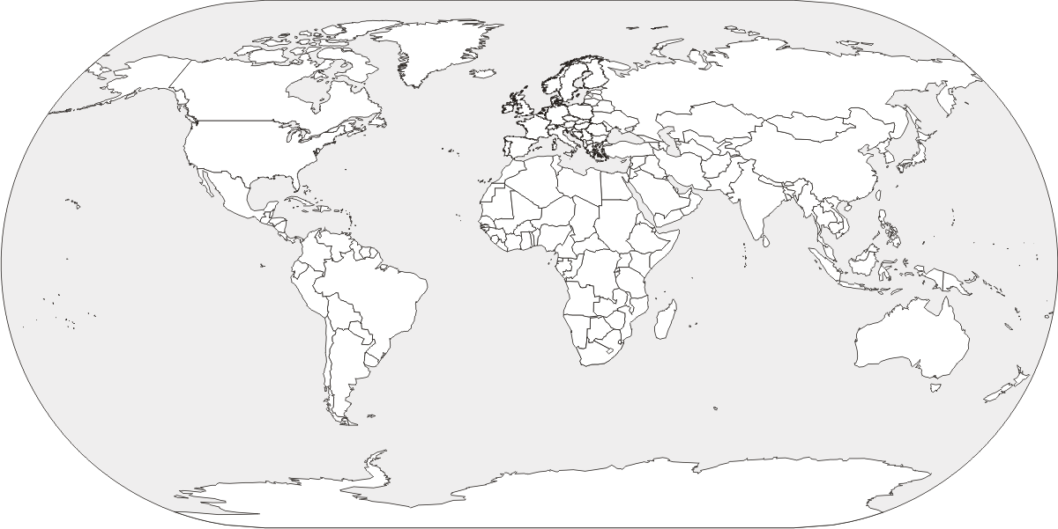
Using your textbook or iPad, label all of the following countries on the map above, which are frequently discussed in the media.
You will need to be able to label any 4 of these countries of your choice for the test.

1. Brazil 3. China 5. Mexico 7. United Kingdom

2. Canada 4. India 6. Russia 8. United States

