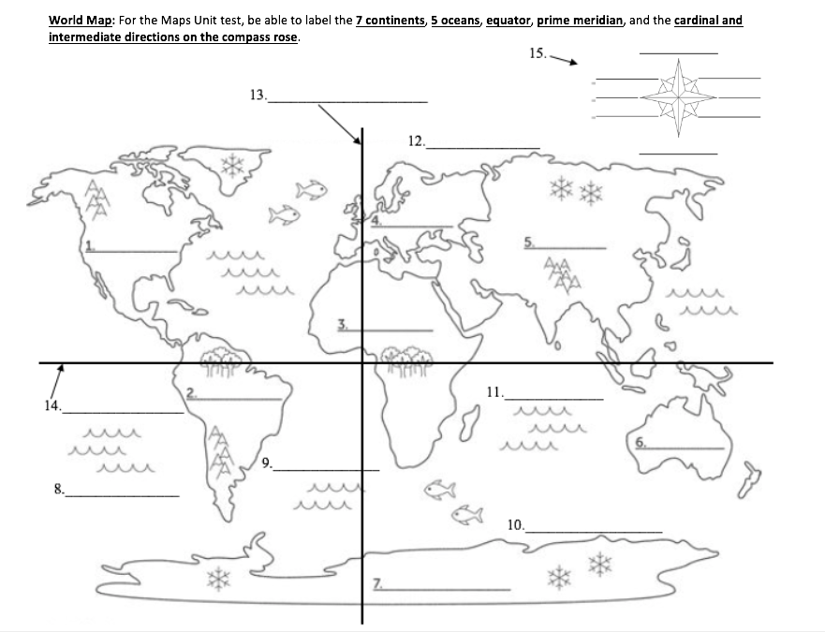**World Map – Maps Unit Test Review**

**Maps Unit Test Review:** Using the atlas in your textbook or iPad, **label ALL of the following 8 countries on the map below**. For the test, you will need to be able to label **ANY 4 of these countries** of your choice.

1. Brazil 3. China 5. Mexico 7. United Kingdom (U.K.)

2. Canada 4. India 6. Russia 8. United States (U.S.)

