Name: ___________________________________ Period: _________ Test date: Wednesday, September 12, 2018 *This review is due the day of the test & will be a grade.

Maps Unit Test Review
Please complete each of the following sections using your Maps Unit packet, a world map, and/or your iPad.

I. Use the map below (or from my website) to answer questions 1-3:

1. What is the title of this map? _____________________________________
*Please note: The title of a map can also be the theme of a map.

2. Looking at the Map Legend, list one of the symbols and what it stands for: ____________________________

3. List two labels shown on the map:
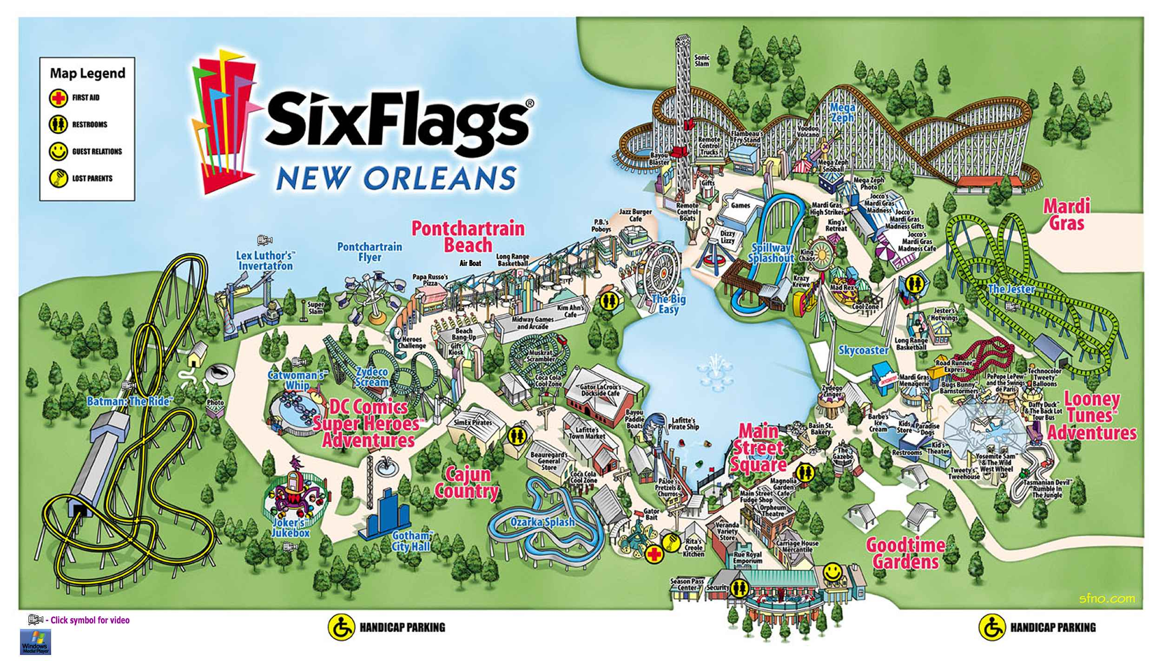 1)______________________________________ & 2)__________________________________________

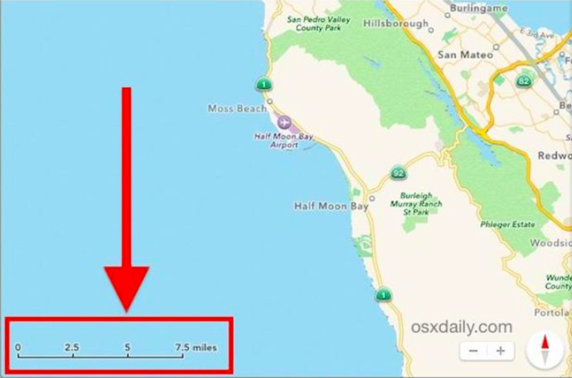

4. Using the scale, approximately
how many miles are between
Moss Beach and Half
Moon Bay? _______________

*You may use a ruler on these
types of questions.

II. Matching: Using your Maps Unit packet or textbook glossary, define the following terms and be able to
match the term with its definition.

5. Political map: ________________________________________________________________________

6. Physical map: ________________________________________________________________________

7. Absolute location: _____________________________________________________________________

8. Hemisphere: _______________________________________________________________________

9. Lines of Latitude: _____________________________________________________________________

10. Lines of Longitude: ___________________________________________________________________

III. Absolute Location: Using the map of the U.S. (also on my website), list the coordinates of the following cities.

N or S of equator (latitude) , E or W of prime meridian (longitude)

Examples: 78°N, 30°W
23°S, 120°E
11. Washington, DC is located at __________________ , __________________
12. New Orleans, LA is located at __________________ , __________________
13. Houston, TX is located at __________________ , __________________
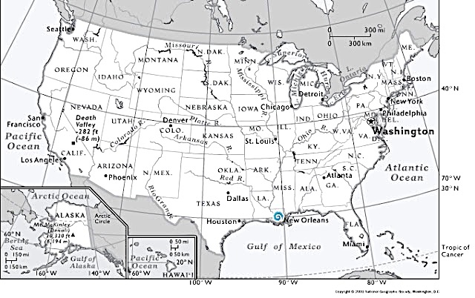
14. Miami, FL is located at __________________ , __________________

