Latitude & Latitude Bingo
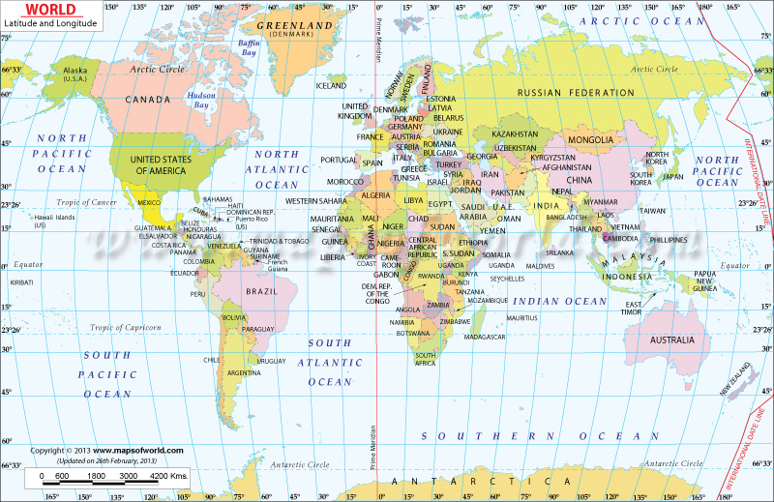
*Remember that coordinates will always list degrees in North or South first, and then East or West (i.e. 38°N, 25°E).

