South Asia “Culture Tour”
Students will color their mandalas as we explore the different countries and cultures of South Asia.
1) India:
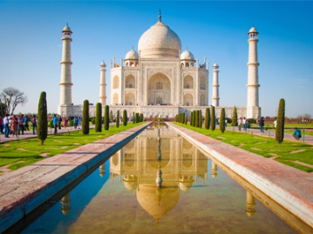
a) Top Tourist Places in India (6:27) – http://viewpure.com/g7xM3p5T0gE?start=0&end=0 1. "Jiya Jale": Berklee Indian Ensemble (music to play for “Top Tourist Places in India” in place of the music on the video): http://viewpure.com/pZy8115sNXM?start=0&end=0 2. YouTube version of "Jiya Jale" (6:57): https://www.youtube.com/watch?v=pZy8115sNXM
b) Festivals:
1. Holi Festival (2:43) - http://viewpure.com/3c3KgQ7CE4I?start=0&end=0
* YouTube version (just in case link doesn’t work): https://www.youtube.com/watch?v=3c3KgQ7CE4I
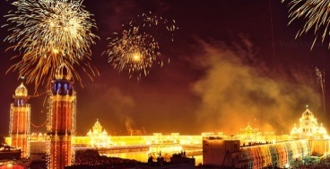
2. Diwali Festival - National Geographic (3:06) - http://viewpure.com/HrrW3rO51ak?start=0&end=0
- The animated legend behind Diwali Festival (4:28) - http://viewpure.com/pp59n0So-XE?start=0&end=0
c) Dance:
1. Top 5 Bollywood Dance Songs (23:10) – http://viewpure.com/TBAj4nbdLEU?start=0&end=0
2. Bhangra – “Panda Panga” Indian Hip-Hop Dance (3:41) - http://viewpure.com/PWKbaAUWQ78?start=0&end=0
3. Cornell Bhangra Indian Fusion Dance Troupe on America’s Got Talent –http://viewpure.com/esaIOkVAlNY?start=0&end=0
e) Hinduism and Reincarnation, a brief explanation (1:40) - http://viewpure.com/KloXPIDYwII?start=0&end=0
d) Guided Meditation to Slow Down (3:20) - http://viewpure.com/Fz_1ujYxT5M?start=0&end=0
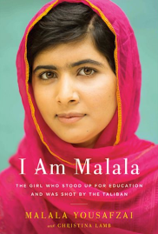
2) Pakistan:
a) 10 Interesting Facts about Pakistan (5:46) - http://viewpure.com/c70eZ8PlOYE?start=0&end=0

3) Maldives:
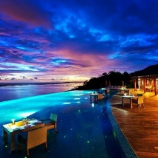
a) The Most Beautiful Place in the World (4:14) - http://viewpure.com/PT0Bi6NQuo4?start=0&end=0

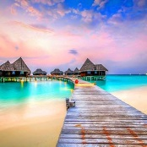
4) Nepal:
a) Discover Nepal (4:12) - http://viewpure.com/UGPxfizP1aI?start=0&end=0
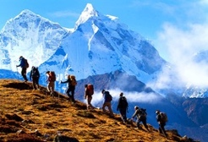
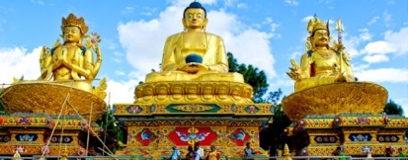
b) Nepal Himalaya Adventure (5:19) - http://viewpure.com/8AliQm4Pk50?start=0&end=0

5) Bangladesh:
a) Top 10 Most Beautiful Places to Visit in Bangladesh (3:37) - http://viewpure.com/4Cr20zd9TJc?start=0&end=0
- Music for Bangladesh video (above):
* Cholo Bangladesh Music Video (2:40) - https://www.youtube.com/watch?v=9ju9O4Ddlww
b) Cricket Highlights – India vs. Bangladesh - https://www.youtube.com/watch?v=aTN9Fl7F9AI
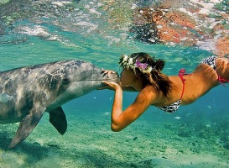
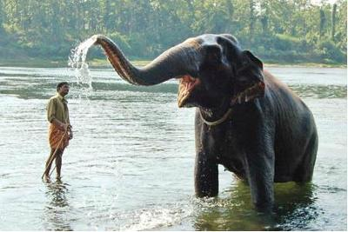
c) Bangladeshi wedding dance (4:37) - https://www.youtube.com/watch?v=wKh83uH0qtY

6) Sri Lanka:
a) Travel to Sri Lanka (5:38) - http://viewpure.com/zpZI2oGPsio?start=0&end=0
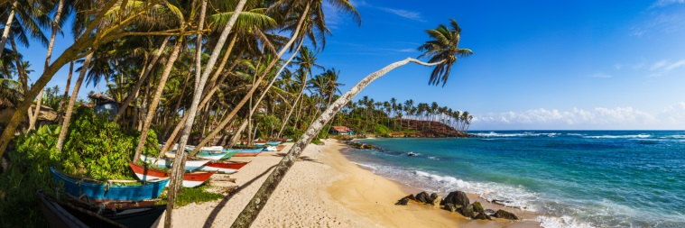
b) Cricket match highlights – Sri Lanka vs. Australia (16:30) - http://viewpure.com/ZxlB0Lnwuo4?start=0&end=0
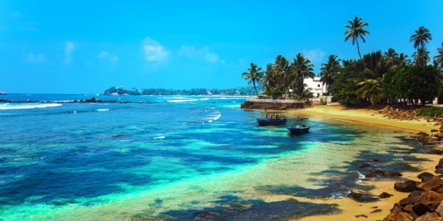

7) Bhutan:
a) Bhutan 2014 - the last paradise (6:10) - http://viewpure.com/yZYxZW-3dos?start=0&end=0
b) Bhutan - The Tiger's Nest in the World's Happiest Country (10:42) - http://viewpure.com/-oeZuOi7Al8?start=0&end=0
c) Bhutan, the mountain kingdom (8:13) - http://viewpure.com/h5T6j3xLSls?start=0&end=0
