Name: _________________________________________________ Period: ________________ Date: _________________________________________
Label the following political and physical features of Australia and New Zealand:
Australian states and territories (political):
1) Australian Capital Territory
2) New South Wales
3) Northern Territory
4) Queensland
5) South Australia
6) Tasmania
7) Victoria
8) Western Australia
Australia (physical):
8) Bass Straight
9) Great Australian Bight
10) Great Barrier Reef
11) Gulf of Carpentaria
12) Indian Ocean
13) Pacific Ocean
14) Tasman Sea
New Zealand (political):
1) North Island
2) South Island
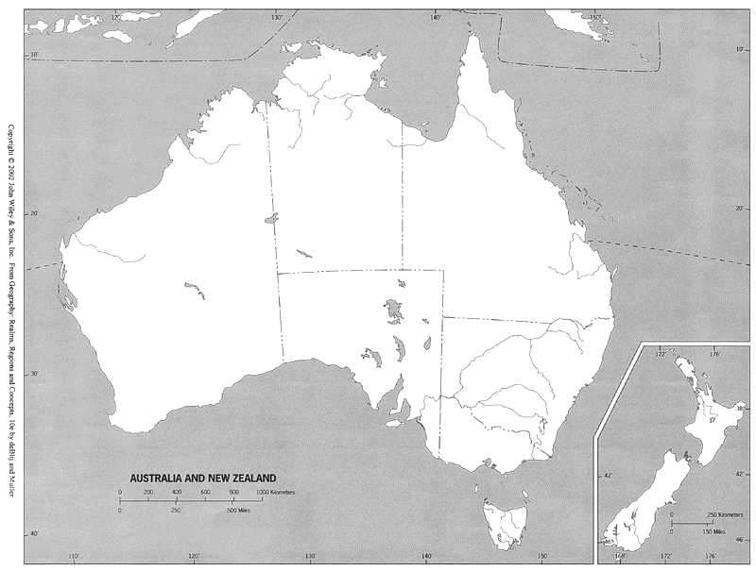
Australia and New Zealand (A36-A39 in textbook)

