Footprints in Time Assignment
**See rubric for specific requirements and grade values**

- Footprint: one side will be an event or invention from B.C. (or B.C.E.); the other side will be an event or invention from A.D. (or C.E.). *Please note: You get to choose your events/inventions!
- Include the date and a brief but detailed explanation of the event or invention in 2-3 complete sentences (please write or type large enough so it can be read from a distance). *You will need to include 2 website citations on your notes for B.C. & A.D., but NOT on your footprint.
- You must have either colored hand-drawn illustrations or actual printed pictures for BOTH sides (2 illustrations on each side).
- One of the sides - B.C./B.C.E. OR A.D./C.E. – must have a 3-D element. You get to choose.
- Your name must be written on both sides (for display purposes).
- Effort always counts! (Neatness, color, interesting details, creativity, conventions, etc.)
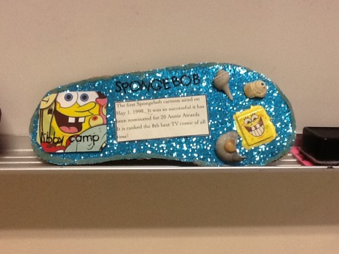
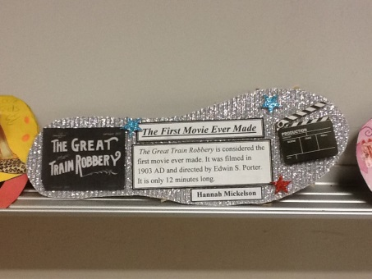
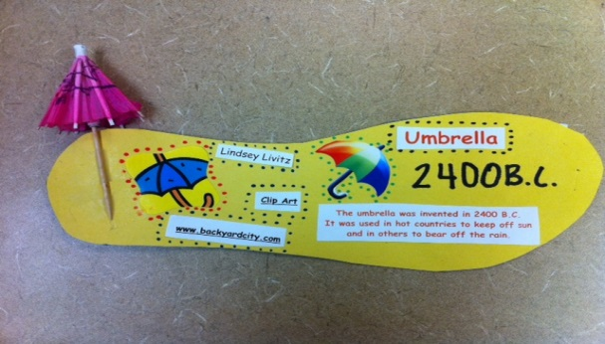

Title & date of A.D./C.E. event/invention: ______________________________

Website(s): _______________________________________________________

Sources for information: ___________________________________________
*Draft for the front of footprint (B.C./B.C.E.)
Title & date of B.C./B.C.E. event/invention: ______________________________

Website(s): ________________________________________________________

Sources for information: __________________________________________
*Draft for the back of footprint (A.D./C.E.)
Use the space below for brainstorming and notes. The two boxes below that are to write the draft for your footprints.
B.C. or B.C.E. event/invention & information: A.D. or C.E. event/invention & information:
_________________________________________________________________________________________________________________________________________________________________________________________________________________________________________________________________________________________________________________________________________________________________________________________________________________________________________________________________________________________________________________________________________________________________________________________________________________________________________________________________________________________________________________________________________________________________________________________________________________________________

Name _________________________________________________ Period __________ Date ____________

B.C./B.C.E. Event/Invention: ___________________________ A.D./C.E. Event/Invention: _____________________________

Time: Footprint Rubric
**This rubric must be turned in with your footprint.

Category | Outstanding | Good | Getting there | Comments
Dates and Information  (40 points)  *2-3 complete sentences must be used for each side, as well as the correct date. | Project has correct dates and interesting, detailed information.  Footprint:  1 B.C./B.C.E.  &  1 A.D./C.E. | Project has most of the correct dates and some detailed information.  Footprint:  1 B.C./B.C.E.  &  1 A.D. /C.E. | Project has very little or vague information; dates are incorrect or missing.  Footprint:  1 B.C./B.C.E.  &  1 A.D./C.E.
Graphics  (30 points)  Graphics may be hand-drawn or computer-generated.  *Magazine  pictures may also be used. | Two graphics for each date and has a 3-dimensional item on one side.  All graphics relate to the event/invention and make it easier to understand. | Only one graphic for each date and/or no 3-dimensional item on one side.  Most graphics relate to the event/invention and make it easier to understand. | Date without a graphic and/or no 3-dimensional item on one side.  -OR-  Only some graphics relate to the event/invention and/or it’s not easy to understand.
Neatness, Readability, and Creativity  (15 points) | All information is clear, meaningful and neatly written (or typed). | Most information is clear, meaningful, and neatly written (or typed). | Very little information is clear, meaningful, and neatly written (or typed).
Grammar/Mechanics  (10 points) | Footprint displays correct grammar, wording, spelling, capitalization, sentence structure and punctuation. | Footprint displays some errors in grammar, wording, spelling, capitalization, sentence structure or punctuation. | Footprint displays several errors in grammar, wording, spelling, capitalization, sentence structure and punctuation.
Websites Used/  Works Cited  (5 points) | At least two websites were used for each side:  B.C./B.C.E.  and  A.C./C.E. | Only one website was used for each side:  B.C./B.C.E.  and  A.C./C.E. | Only one website was cited on one side  -OR-  No websites cited for project.
Websites that will help you find events (but you may search on your own). Please access these sites from my Resources tab: Time Unit resources #6 (Footprint Instructions & Rubric)
1) http://www.krysstal.com/search_inventions.html
2) http://inventors.about.com/od/astartinventions/a/FamousInvention.htm
3) http://ehistory.osu.edu/timeline-events
4) http://timelines.ws/
5) http://www.timelineindex.com/content/home.php
6) http://www.datesandevents.org/events-timelines/09-inventions-timeline.htm

Footprint grade (double-daily) ___________

