Name: ____________________________________________ Period: _______ Date:______________________
Partner(s): _________________________________________ Global issue: _____________________________
Global Issues in Africa – PSA Research Notes
Research your African global issue independently. Remember to use good note-taking format (keywords and phrases, no complete sentences). Your notes will count as an individual daily grade.
1. Clearly state what your global issue is & where in Africa it’s happening: Using specific names and details, state what your issue is, who or what is affected, and in which countries, territories, regions, etc. that this issue is occurring. ______________________________________________________________________________ __________________________________________________________________________________________________________________________________________________________________________________________________________________________________________________________________________________________________________________________________________________________________________________________________________________________________________________________________________________________________________________________________________________________________________________________________________________________________________________________________________________________________________________________________________________________________________________________________________________________________________________________________________________________________________________________
2. Specific details about the global issue & its causes:
Research the “who, where, what, when, why, and how” of your topic using specific names, numbers/statistics, facts, details, and locations to give your audience all the most important background information about your global issue. Refer to your rubric for the other questions to answer. (4-5 facts)
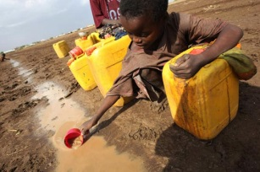
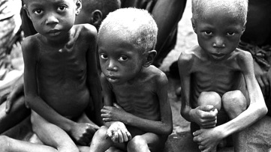
__________________________________________________________________________________________________________________________________________________________________________________ _______________________________________________________________________________________________________________________________________________________________________________________________________________________________________________________________________________________________________________________________________________________________________________________________________________________________________________________________________________________________________________________________________________________________________________________________________________________________________________________________________________________________________________________________________________________________________________________________________________________________________________________________________________________________________________________________________________________________________________________________________________________________________________________________________________________________________________________________________________________________________________________________________________________________________________________________________________________________________________________________________________________________________________________

3. Practical solutions to this problem (3-5 solutions)
a) What can people and kids your age realistically do to lessen or fix this issue on a day-to-day basis? ________________________________________________________________________________________________________________________________________________________________________________________________________________________________________________________________________________________________________________________________________________________________ ________________________________________________________________________________________
b) What are some short-term and long-term ways to fix this issue? ________________________________________________________________________________________________________________________________________________________________________________________________________________________________________________________________________________________________________________________________________________________________
c) List specific organizations, websites, movements, etc. where your classmates could volunteer their time, donate money, or sign petitions to help your cause. (Again, avoid out-of-reach solutions!) ____________________________________________________________________________________________________________________________________________________________________________________________________________________________________________________________________________________________________________________________________________________________________ ___________________________________________________________________________________________________________________________________________________________________________________________________________________________________________________________________________
4) Closing slide: Brief, one-liner or famous quote (include person’s name who is being quoted, if used) to emotionally appeal to your audience to take action. ___________________________________________________________________________________________________________________________________________________________________________________________________________________________________________________________________________
5) Additional notes: This section is not required – it’s to use as needed.
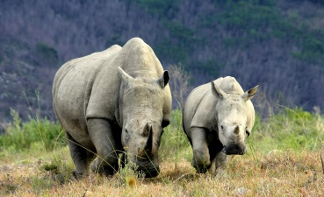
___________________________________________________________________________________________________________________________________________________________________________________________________________________________________________________________________________________________________________________________________________________________________________________________________________________________________________________________________________________________________________________________________________________________________________________________________________________________________________________________________________________________________________________________________________________________________________________________________________________________________________________
Sources ______________________________________________________________ _____________________________________________________________________ _____________________________________________________________________

