Global Issues in Africa– Public Service Announcement (PSA)

You will select a global issue that affects the people, animals, and/or environment in Africa using the links below (or Google search), which you may access on my website. Choose a topic that is near and dear to your heart – it will show and you could start a movement! There will be no overlap on global issues, so first come, first served.

- Global Issues in Africa: http://www.globalissues.org/issue/83/conflicts-in-africa
- General Global Issues: http://www.livebinders.com/play/play_or_edit?id=284406 (click tabs)
- Global Issues: http://www.globalissues.org/article/84/conflicts-in-africa-introduction
- United Nations: http://www.un.org/en/sections/issues-depth/africa/index.html
- The Globalist: http://www.theglobalist.com/issues/
- International Fund for Animal Welfare: http://www.ifaw.org/united-states/solr-search/Africa?filters=
- Coastal East Africa: http://www.worldwildlife.org/places/coastal-east-africa
- Congo Basin: http://www.worldwildlife.org/places/congo-basin
- Madagascar: http://www.worldwildlife.org/places/madagascar
- Namibia: http://www.worldwildlife.org/places/namibia

Instructions: You and your partner will create a PSA/presentation to teach your classmates about your global issue, and offer ways that your classmates can realistically help solve or lessen the problem associated with this problem. You’re encouraged to use iMovie, but may use Google Slides, Keynote, or any other creative app. As always, bring your iPad charged every day and each partner should contribute equally. You will have 2 days to research and 2-3 workdays to put your presentation together.

Tips to make your PSA effective and inspirational:
- Your PSA should be both informative and persuasive to motivate your classmates to take action.

- Make sure the information you research is interesting, accurate, and up-to-date. Use specific facts, details, numbers/statistics, names, locations, and any other important information that will give your classmates a real sense of the issue. NO VAGUE OR GENERIC DETAILS!

- Include colorful pictures related to your topic on every clip or slide, but please do not traumatize your classmates with overly graphic pictures (like elephant poaching). PSAs alternate between sad and sweet pictures to make the audience connect emotionally, whereas traumatic photos typically make people angry and/or avoid the cause altogether to guard their emotions. All of your visuals/graphics should be related to your human, animal, and/or environmental topic (and not a video of you being recorded speaking).

- Your information must be typed on the iMovie or presentation to give your classmates a visual to read from, but if you use iMovie, you may type one line at a time (rather than a series of bullets on one slide) to help the presentation keep moving and more interactive. If using timed transitions, make sure to give your audience enough time to read the information.

- PSAs typically use either music and/or voiceover, which is when you record yourself reading the information from your presentation or script.
  - While music is strongly encouraged for emotional appeal, it is not required. However, the song you choose should match the mood.
  - Likewise, for voiceover, your voice should match the mood (like TV reporters are trained to do) while you read the typed information from your slide. Again, if you use voiceover, please time your slide transitions to give you enough time to read the information from the slide. Also, make sure you can be heard!

- Make sure to use the same order outlined on the rubric (on the other side of this sheet).
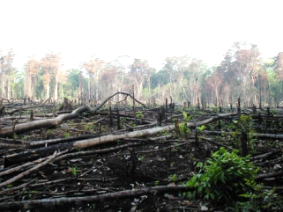
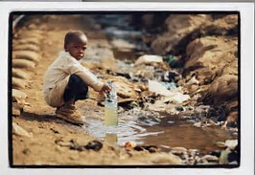
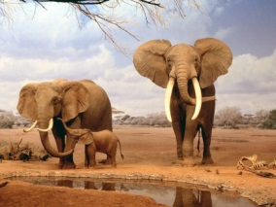

Name: ___________________________________ Partner’s Name: _______________________ Period: ____
Global Issue: ________________________________ Presentation Days: _____________________________

Global Issues in Africa – PSA Rubric
Required elements in your presentation: | Student  Checklist | Teacher  Grade | Teacher comments
1) Title page: Include the global issue (as title), students’ first and last names, class period & picture(s) that draw in your audience. |  | ___/5
2) Clearly state what your global issue is & where in Africa it’s happening: Using specific names and details, state what your issue is, who or what is affected, and in which countries, territories, regions, etc. that this issue is occurring. |  | ___/10
3) World or African Map of the Issue: This should show your audience a map (or graphic) of the area(s) in Africa that your chosen issue occurs. *This may be included on slide #2 above. |  | ___/10
4) Specific details & causes of the problem: This is where you really “sell” your global issue to your audience with specific details about your global issue – why should they care?  a) Research the “who, what, when, where, why, and how” of your topic using specific names, numbers/statistics, facts, details, locations,  and any other hard evidence about your issue that cannot be argued  with (and avoid opinions altogether)  b) Why is this issue happening? Who does it benefit and who or  what is at risk?  c) Who or what is causing this issue?  d) Include any other critical information you find about your topic (i.e. the motivation behind poaching elephants for their tusks the huge amount of money earned by those who live in poverty (which is used for piano keys, pool balls, face creams, etc.)). |  | ___/20
5) Practical solutions to this problem:  a) What can people and kids your age realistically do to lessen or fix this issue on a day-to-day basis?  b) What are some short-term and long-term ways to fix this issue?  c) List specific organizations, websites, movements, etc. where your  classmates could volunteer their time, donate money, or sign  petitions to help your cause. You’re never too young!  Make sure your solutions motivate your audience to do something about it (by avoiding solutions that seem unrealistic, unattainable, or completely out of reach). |  | ___/20
6) Closing slide: This is a famous quote or brief, one-liner that serves as a final emotional appeal to your audience. (Ex: “Be the change you wish to see in the world.” – Mahatma Ghandi). *Include a cute picture! |  | ___/5
7) Works Cited Page: Include all websites you used for your research.  *Minimum of 4 sources required (and include a picture). |  | ___/10
8) Effectiveness: Your group did a great job and followed directions  closely to make the presentation effective, meaningful, and persuasive. |  | ___/10
9) Conventions: While you may use charts and graphs to reinforce your points, please write your research in complete sentences, using correct spelling, grammar, punctuation, and capitalization. |  | ___/10
FINAL MAJOR GRADE |  | ___ / 100
*Again, make sure to use pictures of your topic on ALL SLIDES to “reel in” your audience emotionally.

