Interesting Chinese research topics:
- 12 Signs of the Chinese Zodiac - https://www.travelchinaguide.com/intro/social_customs/zodiac/
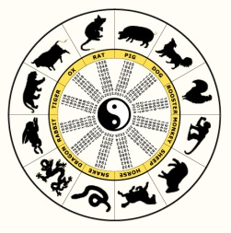
- Year of the Sheep (February 1, 2003 – January 21, 2004): https://www.travelchinaguide.com/intro/social_customs/zodiac/sheep.htm

- Year of the Monkey (January 22, 2004 – February 8, 2005): https://www.travelchinaguide.com/intro/social_customs/zodiac/monkey.htm

- Year of the Rooster (February 9, 2005 – January 28, 2006): https://www.travelchinaguide.com/intro/social_customs/zodiac/rooster.htm

- Meaning of Yin Yang - http://feng-shui.lovetoknow.com/Ying_Yang_Meaning

- Write your name in Chinese (which also provides the Chinese pronunciation of your name) - https://www.chinesetools.eu/names/
- https://www.vecteezy.com/free-vector/chinese-border
- https://www.freevector.com/asian-borders
- From Pinterest: https://www.pinterest.com/explore/chinese-patterns/
- http://all-free-download.com/free-vector/traditional-chinese-border-vector-free.html
(look at links on left for more options)

- Chinese foot binding:
*Please research this independently if you choose to do so, given the sensitive nature of this topic.
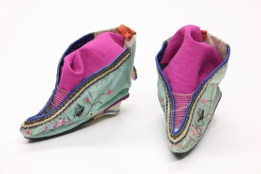
  - Smithsonian: http://www.smithsonianmag.com/history/why-footbinding-persisted-china-millennium-180953971/
  - Encyclopedia Britannica: https://www.britannica.com/science/footbinding
  - http://www.kidzworld.com/article/2142-history-chinese-foot-binding

- The Great Wall of China:
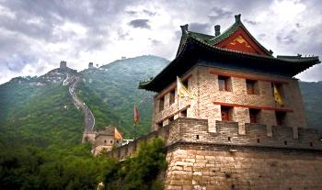
  - Virtual tour: http://www.airpano.com/files/China-Great-Wall/2-2
  - 10 Interesting Facts: http://viewpure.com/ci4N7LsmKT4?start=0&end=0

- Chinese New Year - http://www.history.com/topics/holidays/chinese-new-year
- Dragon culture in China - http://traditions.cultural-china.com/features/dragon/
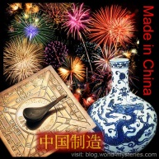
- Chinese inventions (ideas for Museum Day):
  - http://www.ducksters.com/history/china/inventions_technology.php
  - Timelines:
    - http://www.tiki-toki.com/timeline/entry/427085/Chinese-inventions-Timeline
    - https://www.timetoast.com/timelines/chinese-inventions-and-innovations--11

- The Grand Canal and its lock system – http://www.ducksters.com/history/china/grand_canal.php
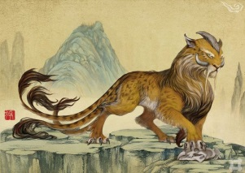
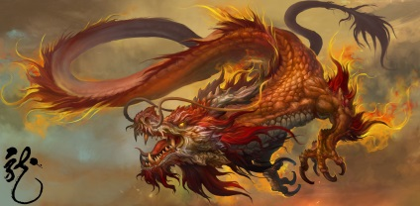
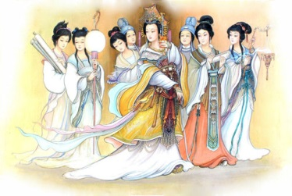
- Chinese mythology - http://www.ducksters.com/history/china/chinese_mythology.php

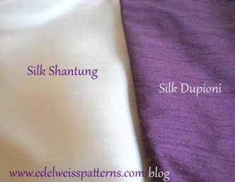
- The Legend of Silk - http://www.ducksters.com/history/china/legend_of_silk.php
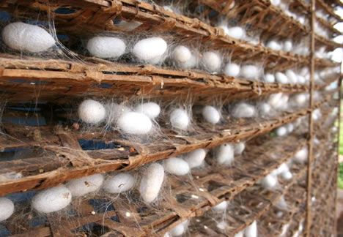

- The Terracotta Army:
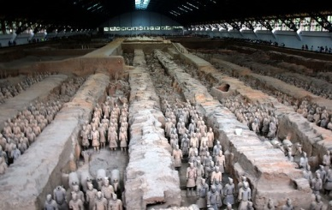
  - National Geographic video: http://video.nationalgeographic.com/video/exploreorg/china-terra-cotta-warriors-eorg
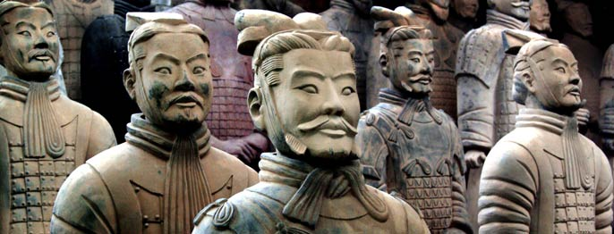
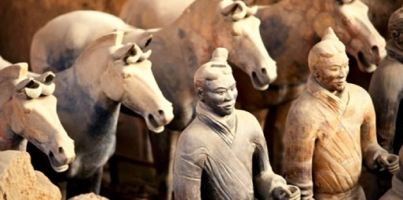

- The Forbidden City – Beijing, China
  - 3-D Tour - http://viewpure.com/RrbkJGIVzOM?start=0&end=0
  - Lonely Planet travel video (2:10) - http://viewpure.com/LyR2-hriJFo?start=0&end=0
  - Documentary Series (awesome!): https://wn.com/documentary_inside_the_forbidden_city

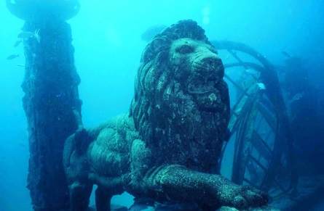
- Lion City – the Atlantis of China - http://www.dailymail.co.uk/news/article-2561147/Chinas-Atlantis-How-Lion-City-purposely-flooded-make-way-power-station-remains-completely-intact-130ft-underwater-50-years.html
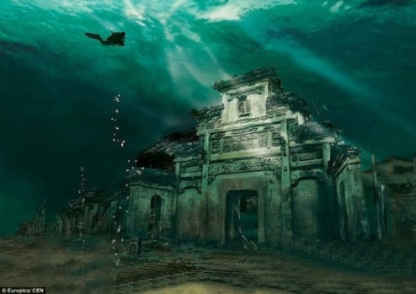

- China/Tibet conflict - https://freetibet.org/about/china-argument

