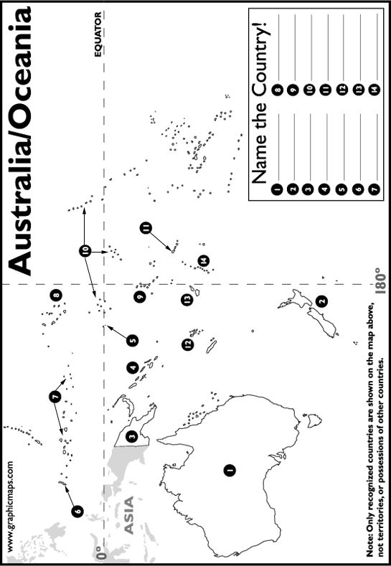
Name: ___________________________________________________ Period: _____________ Date: _______________________________
Using your iPad or A36-A39 in your National Geographic textbook, label the following countries. A map is also posted under Australia and the Pacific Realm resources.

