Name: __________________________________ Period: __________ Map grade: _________________

Map of Southeast Asia
Using A34-A35 in your National Geographic textbook or your iPad, label each of the following political and physical features of Southeast Asia. Please follow the instructions as listed below.
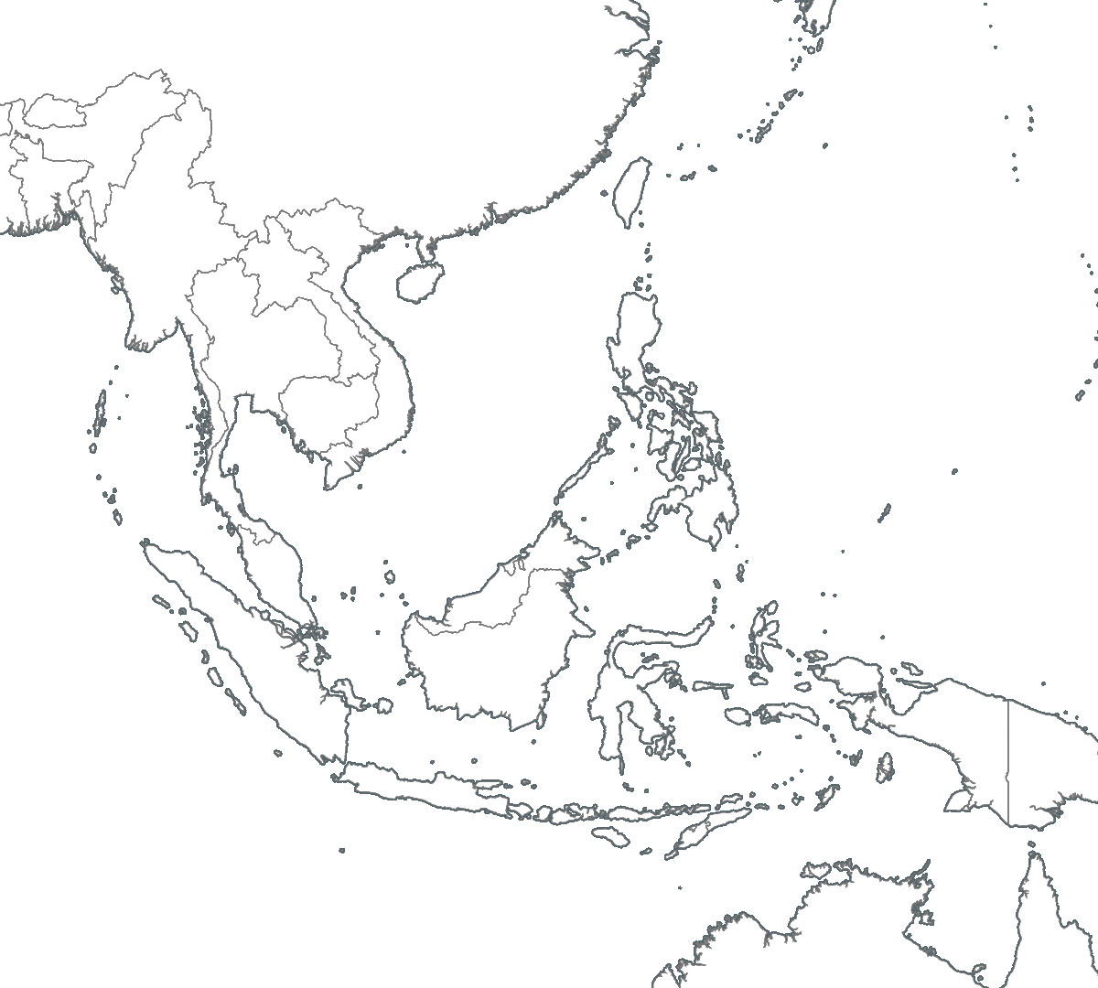

Countries of Southeast Asia  Label and outline each of the following countries in various colors to distinguish each country’s borders. |  | Major Bodies of Water  Label each of the following bodies of water in blue.
1. Brunei | 6. Myanmar | 1. Andaman Sea
2. Cambodia | 7. Philippines | 2. Indian Ocean
3. Indonesia  *Also label these 6 islands (located within  the country of Indonesia): Bali, Borneo, Java,  New Guinea, Sumatra, and Timor | 8. Singapore | 3. Java Sea
 | 9. Thailand | 4. Pacific Ocean
 | 10. Timor-Leste | 5. Philippine Sea
4. Laos | 11. Vietnam | 6. South China Sea
5. Malaysia |  | 7. Timor Sea

