Name: _____________________________________ Period: _________ Date: _________________________
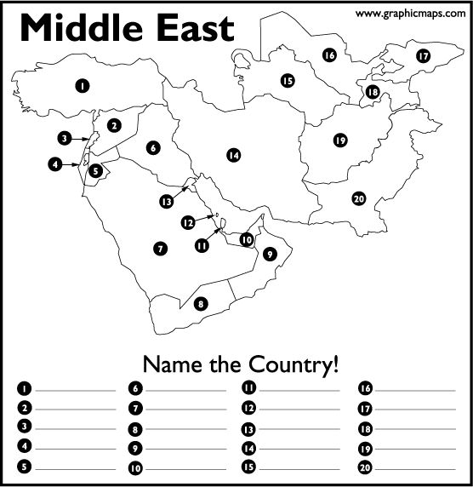
Using A29 in your National Geographic textbook or your iPad, please fill in the following countries of the Middle East. Please note: This region of the Middle East is part of Asia.

1. __________________________________________ 11. ___________________________________________
2. __________________________________________ 12. ___________________________________________
3. __________________________________________ 13. ___________________________________________
4. __________________________________________ 14. ___________________________________________
5. __________________________________________ 15. ___________________________________________
6. __________________________________________ 16. ___________________________________________
7. __________________________________________ 17. ___________________________________________
8. __________________________________________ 18. ___________________________________________
9. __________________________________________ 19. ___________________________________________
10. __________________________________________ 20. ___________________________________________

Physical Map of the Middle East
Using A28 in your National Geographic textbook or your iPad, please follow the instructions below to complete the physical map of the Middle East.
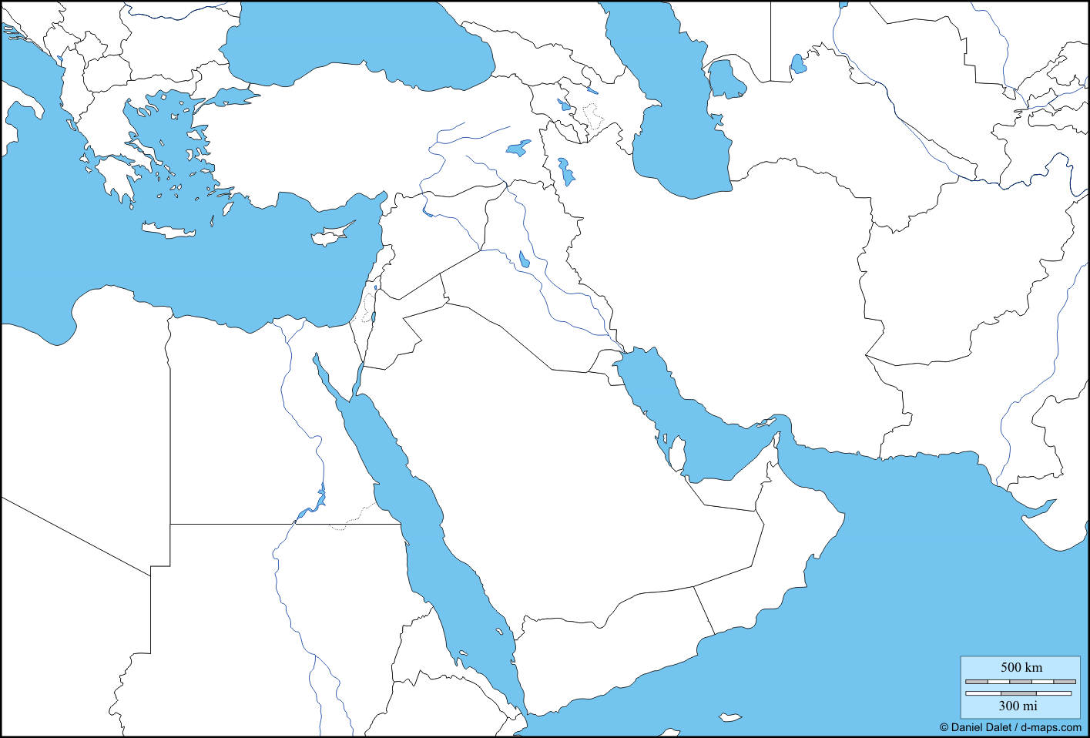

Outline/trace & label each of the following bodies of water in blue.
1. Arabian Sea | 7. Indus River
2. Black Sea | 8. Mediterranean Sea
3. Caspian Sea | 9. Nile River (in Northern Africa)
4. Dead Sea | 10. Persian Gulf
5. Euphrates River | 11. Red Sea
6. Gulf of Oman | 12. Tigris River

Draw/outline & label each of the following landforms, using the specified colors below.

Deserts Brown Other landforms Green Mountains
1. Anatolia (Anatolian Plateau) | 5. Rub al Khali Desert (“Empty Quarter”)
2. Arabian Peninsula | 6. Syrian Desert
3. Hindu Kush Mountains | 7. Taurus Mountains
4. Mt. Ararat | 8. Zagros Mountains

