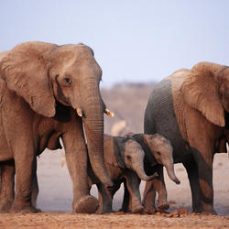
Examples of Effective PSAs
Animals:
- Sarah McLachlan SPCA commercial (2:00): http://viewpure.com/crEEpGDtcL8?start=0&end=0
- Adopt a Pet PSA (2:12): http://viewpure.com/9c8hXjC_jtU?start=0&end=0
- Animal welfare (various videos): http://viewpure.com/U_rA-djBEvc?start=0&end=0
- Animal Cruelty PSA (1:12): http://viewpure.com/pllPHFO3rCE?start=0&end=0

Environment:
- Global warming (1:04): http://viewpure.com/DP1upzy4RWE?start=0&end=0

Human Rights:
- Conflict diamonds (3:55) http://viewpure.com/1Nb3f5Ugzqk?start=0&end=0
- Anti-bullying PSA (4:08): http://viewpure.com/N9k1sAav4Tc?start=0&end=0
- Kids Playground Anti-Bullying video (1:58): http://viewpure.com/-yRGGt7nJOM?start=0&end=0
- Pink - Perfect (AHMIR cover) - Anti-Bullying video (4:54): http://viewpure.com/gliHyklHr6c?start=0&end=0
- Children in Africa: HIV/AIDS PSA 2014 (2:57): http://viewpure.com/CjG1K6EA8IU?start=0&end=0
- Poverty in Africa (1:33): http://viewpure.com/nZwe2VFz2jw?start=0&end=0
- Child Labor in Gold Mines (1:34): http://viewpure.com/Pi5HzZ9ZgYk?start=0&end=0
- Child soldiers (1:50): http://viewpure.com/EcGBL7xRwIM?start=0&end=0
