Name: ____________________________________ Period: _________ Date: __________________________

**Russia – Early History to Modern Times**

(National Geographic textbook)

**I. Early History – pp. 320-321**

1. Settlement of Russia by different groups dates back to what year? ___________________________

**a. Kievan Rus**:

2. Which ethnic group had the most cultural influence on early Russia? ____________________________

3. Which Viking tribe is it believed that Russia got its name? _____________________________________

**b. Mongol Rule and Trade:**

4. Which Mongol ruler took over much of Russia in 1240? _______________________________________

5. With the Mongols in power, which ancient trade route did the Russians have access to that brought new ideas and goods (such as gold, jade, and silk)? ____________________________________________

**c. The Rise of Moscow**

6. Which Russian leader gained independence from the Mongols in 1480? ___________________________

7. Which leader expanded Russia into an empire and became Russia’s first czar? ______________________

**II. European or Asian? – pp. 322-323**

**a. Spanning Europe and Asia:**

8. Russia spans two continents, which is referred to as what? ____________________________________

9. Which mountain range separates the two continents? ________________________________________

10. The most populated cities in Russia are on which continent? _______________________________

11. Which branch of Christianity did Russia practice? _______________________________________

**b. European Influence:**

12. Which czar modernized Russia to be more like Western Europe in the areas of government, business, architecture, etc.? ______________________________________________________________________

13. Which leader introduced European ideas in the arts, education, entertainment, healthcare, laws, and the church? ________________________________________________________________

**III. Serfdom to Industrialization – pp.326-327**

**a. The Beginning of Serfdom**

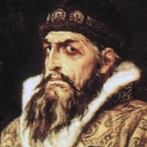14. What nickname was the first czar of Russia, Ivan IV, given? ___________________________________

15. What crime did Ivan IV commit to earn his nickname? _________________________________ ________________________________________________________________________________ ________________________________________________________________________________

**\*Reflect on prior knowledge:** Ivan passed laws that tied peasants to the land as serfs (who had their own small houses, a plot of land to farm, but had to pay the landlord rent, could not leave the estate without permission, and had few rights). What system does this remind you of from the Middle Ages?

**-** The ___________________ System

16. Which czar freed the serfs in 1861 to work in industry and modernize Russia? _____________________

**b. Industrial Revolution in Russia**

17. While the Industrial Revolution began in the 1700s, when did it begin in Russia? __________________

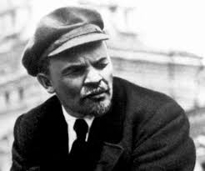18. Much like the conditions of the Industrial Revolution in other countries, industrial workers were very poor and working conditions were harsh. This gave rise to strikes and protests, which then gave rise to what? _________________________________________________

19. Which revolutionary activist and politician led the Bolshevik Revolution? ________________________

20. What two things did the Bolsheviks want to control?

1) _____________________________ and 2) _________________________________

21. What happened as a result of the Russian Revolution in February of 1917? _________________________________________________________________________

22. Looking at the map on p.327, why do you think the Russians were so far behind Western Europe in producing weapons for World War I? _________________________________________________________ _______________________________________________________________________________________

**IV. The Soviet Union – pp. 328-329**

23. The Bolsheviks, who led the Russian Revolution in 1917, believed in what form of government? ___________________________ And what kind of economic system? ______________________________

24. Under this new form of government, Russia became the Soviet Union (or U.S.S.R.). What does U.S.S.R. stand for? ______________________________________________________________________________

*The Soviet Union had a powerful central government that controlled the region from the year

____________ until the year ____________ (with the collapse of the Cold War).

25. During what years did Joseph Stalin rule? _____________________________________________

**a. The Cold War:**

26. After WWII, which two countries were the most powerful in the world?

1) ___________________________ and 2) ____________________________

27. What caused the tension and conflict between these two countries? ______________________________ _______________________________________________________________________________________

28. Why was this conflict known as the Cold War? ______________________________________________ _______________________________________________________________________________________

29. What kinds of weapons did each country develop during this time? ______________________________

30. Why did the U.S. go to war in Korea in the 1950s and in Vietnam in the 1960s? ____________________ _______________________________________________________________________________________

31. How did the Soviet Union win the space race in 1957? ________________________________________ _______________________________________________________________________________________

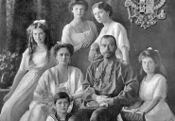

**Some interesting topics to research after you finish:** * Soviet GULAG camps

* Czar Nicholas II & the Russian Revolution * The Sputnik launch

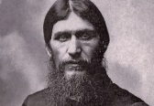* Rasputin (a member of Czar Nicholas’s court) * The Korean & Vietnam Wars

* Joseph Stalin – what made him so bad? * The fall of the Berlin Wall

* Senator Joseph McCarthy & the Red Scare * Bay of Pigs & Cuban Missile Crisis

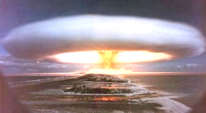* The hydrogen bomb & “Castle Bravo” * Space race & arms (weapons) race