Name: _______________________________ Period: ________ Date: _____________________ Grade: _______
Southeast Asia: Physical Geography and History
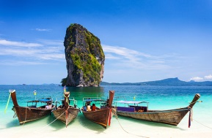
From the National Geographic textbook – read and answer the questions from the page numbers listed below.

I. Physical Geography – pp. 598-599:
1. Southeast Asia is made up of what two types of countries? 1) __________________________ and 2) _____________________________
2. Define land bridge: _____________________________________________________________________
3. What separated Indonesia and the Philippines more than 6,000 years ago? __________________________ _____________________________________________________________________________________
4. The majority of people in Myanmar, Laos, Vietnam, Cambodia, and the surrounding regions live in small villages in which three types of areas? 1) _______________________, 2) _______________________, and 3)_____________________________
5. Bangkok is the most developed and densely populated city in which country? ________________________
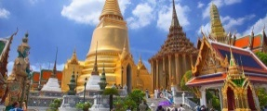
* Bangkok is located in which river delta? ____________________________________
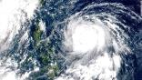

6. Define typhoon: ________________________________________________________________________ *Using your iPad, what’s the difference between a typhoon and a hurricane? _________________________ _______________________________________________________________________________________
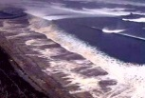
7. What is the Ring of Fire? _________________________________________________________________ ______________________________________________________________________________________ *Using your iPad, what are some of the natural disasters that occur in the Ring of Fire? ________________ ______________________________________________________________________________________
8. What is the primary cause of tsunamis? ___________________________
9. How many people died in the 2004 tsunami near Sumatra? _______________________________________ * After you finish your guided notes, you may research more details about this devastating natural disaster.
II. Ancient Valley Kingdoms – pp. 608-609

10. Which two powerful civilizations influenced Southeast Asia’s cultural direction? 1) __________________ and 2) _______________________________
11. The impact of these two powerful civilizations came to Southeast Asia through what three things? 1) ____________________________, 2) _______________________, and 3) ______________________
12. Which two religions were brought to Southeast Asia as a result of trade with India? 1)_____________________________ and 2)_____________________________
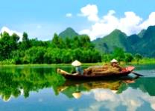
13. What was the name of the largest and longest lasting empire in Cambodia? ________________________ a. Which river valley was this empire centered along? _____________________________________
14. Which Hindu temple was built in Cambodia by King Suryavarman II? ____________________________ a. Which Hindu god was this temple dedicated to? _________________________________ b. What other purpose did this temple serve? _________________________________________________
15. Looking at the timeline, China ruled Vietnam from (years) _________________ - _________________ a. In what year did China later reconquer Vietnam? _____________________
16. Which waterway was an important trade route and a center of trade between South Asia and China (that had been controlled by Srivijaya)? _____________________________________________________
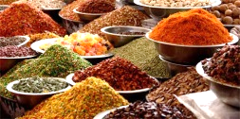
17. What do the three levels symbolize in the Borobudur temple in Java, Indonesia? ____________________ _____________________________________________________________________________________
III. Trade and Colonialism – pp.610-611
18. When did Europeans arrive in Southeast Asia? ________________________ a. What were merchants hoping to establish in this area? ________________________________________ b. Define monopoly: ____________________________________________________________________
19. Which spices could be found in this area? ___________________________________________________
20. While Spanish and Portuguese traders came first, which country dominated the region for years? _______ _____________________ What company did this country establish? ______________________________ *Reflect: Which country established a similar company in India? _____________________________
21. What three things allowed European powers to dominate most of Southeast Asia by 1850? 1) _____________________________, 2) _________________________________________ and 3)________________________________
22. Which 4 European countries controlled most of Southeast Asia? 1) _______________________, 2) _______________________, 3) _______________________, and 4) ___________________________
23. What is it called when a country rules or controls another country and develops trade for its own benefit? _____________________________________________
Read the boxes on pp. 610-611 to answer the following questions.

24. Which explorer landed in the Philippines? ___________________________________ a. For which country did he claim the Philippines? _____________________________
b. Using your iPad, what happened to this explorer? ____________________________________________

25. What event disbanded the French East India Company? _______________________________________
26. Which country founded Singapore? _______________________________________
27. Which event allowed the Dutch to become a major power in the spice trade? _______________________ ______________________________________________________________________________________
28. Using pp. 610-613 or your iPad, which other two countries controlled the Philippines over time? 1) ___________________________ and 2) ______________________________
29. Looking at the map on p.611, which country (or countries) ruled most of Southeast Asia c.1895? ______________________________________________________________________________________

30. From the map, which region of Southeast Asia remained independent from European rule? ____________

